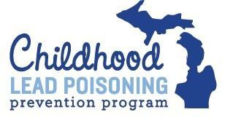
Michigan Lead Poisoning | Name of Child:
Prevention Program | Date of Birth:
Referral Tracking Form | MRN:

Nutrition | Health | Child Development | Housing
WIC | INSURANCE: Healthy Kids MlChild | HeadStart/ Early Head Start | Environmental Investigator
Received  Referred: | Received  Referred: | Received  Referred: | Received  Referred:
Date | Date | Date | Date
 | Chelation Services/ Lead Poisoning Pediatric Consultants | Early On (EBLL>5) or other noted developmental delay | MDHHS Healthy Homes Section
 | Received  Referred: | Received  Referred: | Received  Referred:
 | Date | Date | Date
 | Hospitalization
Received
Referred:
 | Date
 | Children's Special Health Care Services (all children who have been chelated are eligible)
Received
Referred:
 | Date
Common Referral Options
Date of Referral | Name of Agency | Contact at Agency | Type of Referral | Reason for Referral | Date Services Began | Notes
Revised 4/20/16 1

