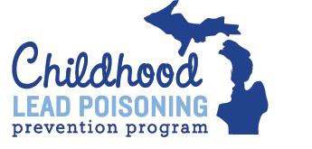

Did You?
Second Visit Checklist

- Finish any of the following assessments:
  - Health/Physical
  - Nutrition
  - Social
  - Developmental

- Educate and inform by leaving any of the following brochures:
  - Safe Cleaning
  - Nutrition
  - Pet Safety
  - Pregnancy
  - Other

- Leave any of the following referral resources for the family?
  - Health
  - Housing/Abatement
  - Food
  - Medical
  - Other

- Recommend follow-up testing (Y/N). If Yes, by when?

- Schedule a follow-up visit? If yes, for what date?

****************************************************************************** Are you prepared to (or have you) completed the following forms:
  - Individual Plan of Care (update if needed)
  - Follow-Up Visit Form
  - Referral Form (if needed)
  - Case Activity Log
  - Report to Health Care Provider and Medicaid Health Plan
  - Billing Spreadsheet

1

