MICLEAR Case Management Quick Reference Guide
The MICLEAR Case Management is a web-based application that is designed for nurses and community health workers (CHWs) to keep track of patients with elevated blood lead levels. Nurses and CHWs (MICLEAR users) can log activities and case notes; look up individual test results, locate previous and current address(es); and attach files to individual cases. Patients shown are for the local jurisdictions only.
Note: This is quick guide for using MICLEAR Case Management, for more detailed instructions you can access the MICLEAR User Manual in the Resources tab in the MICLEAR application.
Accessing MICLEAR Case Management
Go to MiLogin to access MICLEAR, click Search, then Patient to access MICLEAR Case Management.
MICLEAR Case Management Login Requirements
All users are required to log into the MICLEAR application at least once every 30 days upon receiving access from CLPPP. After 60 days of inactivity, the user’s access to the application will be disabled.
It is the responsibility of the user and the user’s supervisor to inform CLPPP staff when access to the system is no longer needed, and when there are changes in the user’s contact information, i.e., phone number, email, fax number. CLPPP staff should also be notified if a user is going to be out of the office for an extended period of time and include a tentative return date.
Required MICLEAR Case Management Documentation
- Required documentation in MICLEAR Case Management:
  - Consent and Release of PHI for Nursing Case Management (use local agency consent documents, follow local agency policies as required).
    - Scanned and uploaded in the “Files” tab.
Initial Home Visit
- Initial Home Visit Form (nurses only)
    - Create an Initial Home Visit Form within the Forms section in MICLEAR within 3 business days of visit.
      - If the form takes more than one home visit to complete, save the form after your first visit and enter an Initial Home Visit Event with a narrative note.
      - All required fields must be completed before submitting the form in MICLEAR.
      - Once the completed form has been submitted, MICLEAR will automatically create an Initial Home Visit Event.
    - Cases opened prior to October 1st, 2025
      - Initial Home Visit was completed using pdf version of form.
        - Scan and upload Initial Home Visit form as patient attachment within 3 business days.
        - Documentation as an “Event”.
        - If the form takes more than one home visit to complete, upload the form after completion and make note in the “Event”.
- Social Determinants of Health (SDOH) Assessment (CHWs only)
    - Create Initial Home Visit Event in MICLEAR within 3 business days of visit.
    - Scanned and uploaded in the “Files” tab.
    - Document referrals as Referral Event in MICLEAR.

- Individualized Plan of Care (nurses only)
    - Developed at Initial Home Visit.
      - Initial Home Visit Form in MICLEAR must be initiated before the Plan of Care can be accessed.
    - Create an Individualized Plan of Care within the Forms section of MICLEAR. If applicable, also create an Individualized Plan of Care Chelation Addendum.
    - Updated electronically, ongoing with case management activities.
    - Plan of Care will close when the patient’s case is closed.
      - Ongoing interventions will be changed to not completed at time of case closure.
    - Cases opened prior to October 1st, 2025
      - Individualized Plan of Care documented using pdf version of form.
        - Scanned and uploaded as patient attachment.
        - Updated locally on paper ongoing with case management activities.
        - Scan updated, completed Plan of Care as patient attachment at case closure.
Follow up visit
- Follow-Up Visit (nurses only)
    - Document interventions provided during home visit on the Plan of Care within the Forms section in MICLEAR within 3 business days of visit.
    - Create Follow Up Home Visit event in MICLEAR.
    - Cases opened prior to October 1st, 2025
      - Follow-Up Home Visit form documented using pdf version.
        - Scanned and uploaded as patient attachment.
        - Be sure to indicate on form if revisions or updates were made to the Plan of Care.
        - Documentation in “Events” and uploaded attachment within 3 business days of visit.
- SDOH form (CHWs)
    - Complete SDOH Assessment Form if unfinished during the initial home visit.
    - Scanned and uploaded in the “Files” tab.
    - Create Follow Up Home Visit Event in MICLEAR within 3 business days of visit.
    - Document referrals as Referral Event in MICLEAR.
All communications: Phone calls, texts, letters, faxes, emails
    - Each communication with providers, parent/guardian, poison control, and community resources will be documented as an Event. Other communication relevant to the Plan of Care should be documented.
    - Documentation in “Events” within 3 business days of the communication
Referrals
    - All referrals will be documented in MICLEAR Case Management as an Event
    - Documentation “in events” within 3 business days of referral

MICLEAR Case Statuses
Case Status | Case Type | Criteria
N/A | N/A | A child that has never had any result ≥3.5µg/dL
Unconfirmed | N/A | A child that has a capillary result ≥3.5µg/dL that has not received a confirmatory venous result
Open | Eligible | A Venous confirmed case in which the family has not accepted case management services yet
Open | Managed | A Venous confirmed case in which the family HAS accepted case management services yet  Automatic creation when Accept is selected within the dropdown for “Did Family accept NCM Services” in any event within MICLEAR
Closed | Eligible or Managed or N/A | Cases that have met closure criteria and the case has been closed by the PH Nurse
Not A Case | N/A | A child that had a Capillary result ≥3.5µg/dL and the confirmatory venous result was NOT ELEVATED (<3.5µg/dL)

Blue Information Box
On the left side of every page, there is a hovering blue box with an “i” on it.
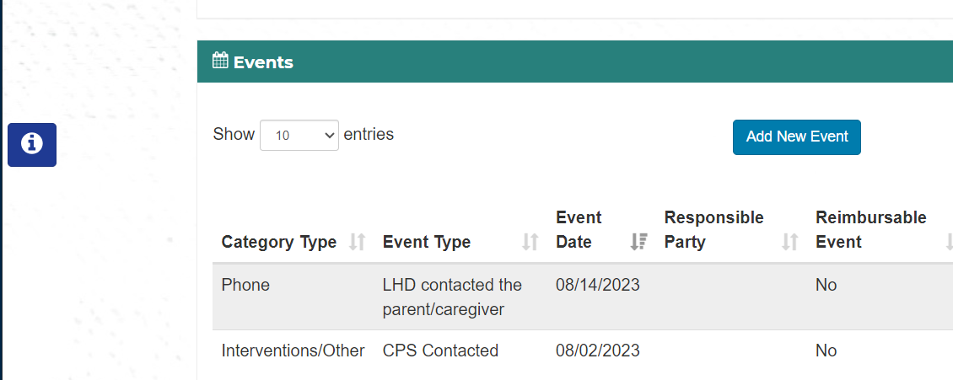
- This box provides brief information on the patient page you’re currently on. The box will remain just an “i” until you click it, when it then reveals patient name, DOB, MICLEAR ID & HHLPSS ID (if applicable). The box can be collapsed again by clicking the “i” again.
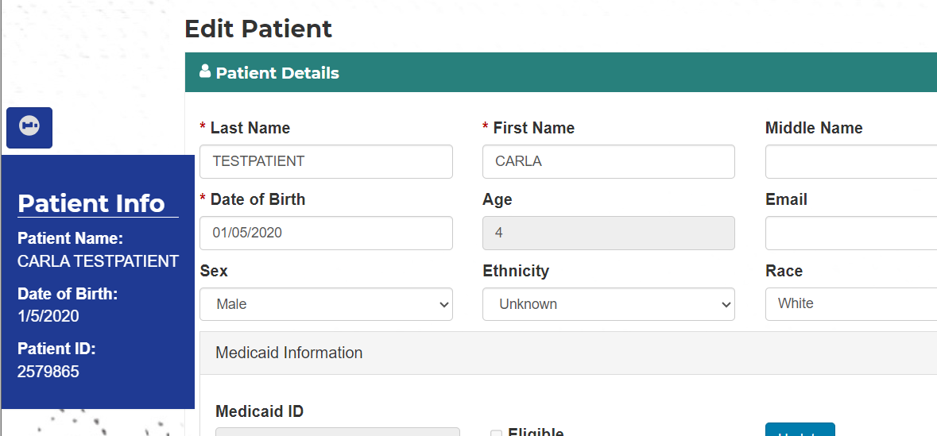

Adding Events:
For each activity done with the patient, an event must be recorded using these steps.
Go in the Patient’s Case Details tab.
To add an Event, click on the Add New Event button in the Events tab.
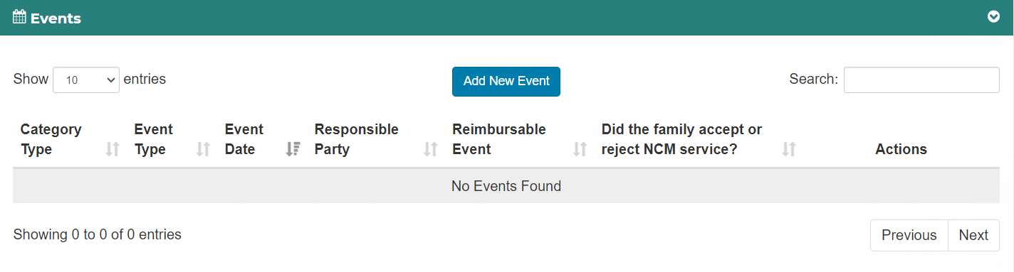

When you select an Event Category a popup will open specific to that selection. The selections are:
- Home Visit
- Text
- Phone
- Letter
- Interventions/Other
- Referral
- Email
- In Person Contact Attempt

Adding a Home Visit event
A popup will open with the following fields:
- Event Category – Home Visit
- Event Type
  - Initial Home Visit – In Person
  - Initial Home Visit - Phone
  - Follow Up HV – In Person
  - Follow Up HV - Phone
- Date Completed
- LHD Responsible Party
- Are Education Materials Provided – yes, no
- Length of Conversation – how long was the visit
  - Unanswered/Not home
  - <5 Minutes
  - 5 - 15 minutes
  - 16 – 30 minutes
  - 31- 60 minutes
  - > 1 hour
- Did you offer NCM services? Yes, no
- Did the family accept NCM services? Accept, Reject, Unknown/unresponsive
- Comments
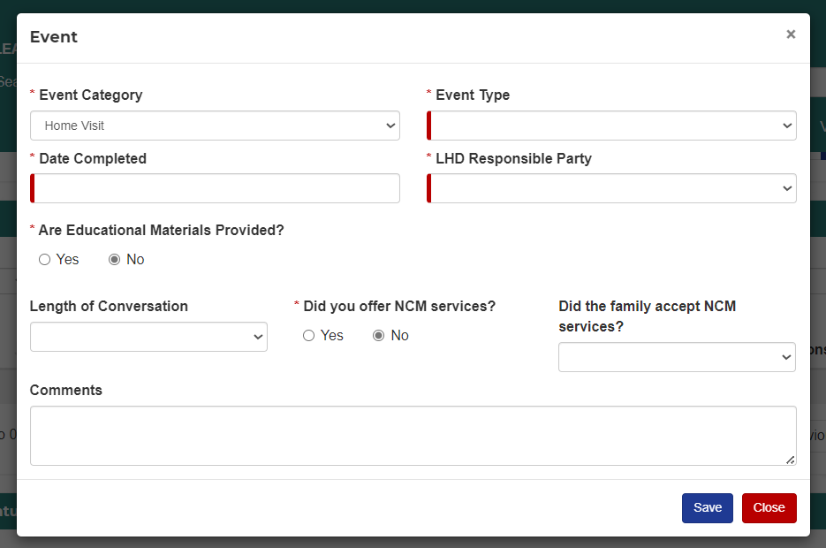
Adding a Text event
A popup will open with the following fields:
- Event Category - Text
- Event Type
  - LHD contacted the parent/caregiver
  - LHD contacted the provider
  - LHD contacted community partners
  - LHD contacted MDHHS Nurse Consultant
  - LHD contacted other – comment required
  - Parent/caregiver contacted the LHD
  - Provider contacted the LHD
  - Community Partner contacted LHD
  - MDHHS Nurse consultant contacted LHD
  - Contact Lead Safe Home
  - Other contacted LHD – comment required
- Date Completed
- LHD Responsible Party
- Are Education Materials Provided?
- Did the Parent/Guardian respond?
- Comments
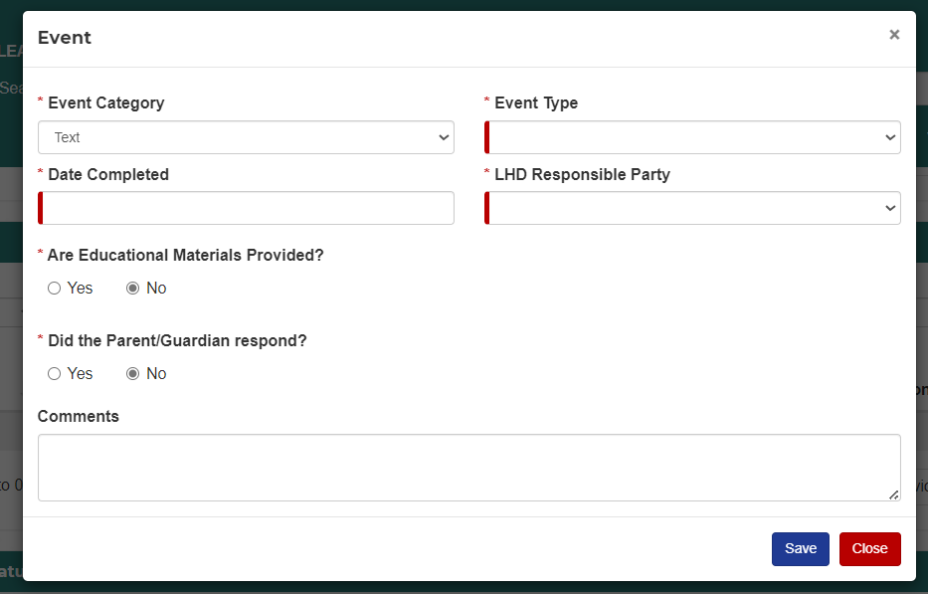
Adding a Phone event
A popup will open with the following fields:
- Event Category - Phone
- Event Type
  - LHD contacted the parent/caregiver
  - LHD contacted the provider
  - LHD contacted community partners
  - LHD contacted MDHHS Nurse Consultant
  - LHD contacted other – comment required
  - Parent/caregiver contacted the LHD
  - Provider contacted the LHD
  - Community Partner contacted LHD
  - MDHHS Nurse consultant contacted LHD
  - Contact Lead Safe Home
  - Other contacted LHD – comment required
  - Health Plan
- Date Completed
- LHD Responsible Party
- Are Education Materials Provided?
- Length of Call
  - Unanswered
  - <5 Minutes
  - 15 minutes or less
  - 16 – 30 minutes
  - 30 minutes or longer
  - > 1 hour
- If Parent/Guardian is selected in Event Type
  - Did you offer NCM services? Yes, no
  - Did the family accept NCM services? Accept, Reject, Unknown/unresponsive
- Comments
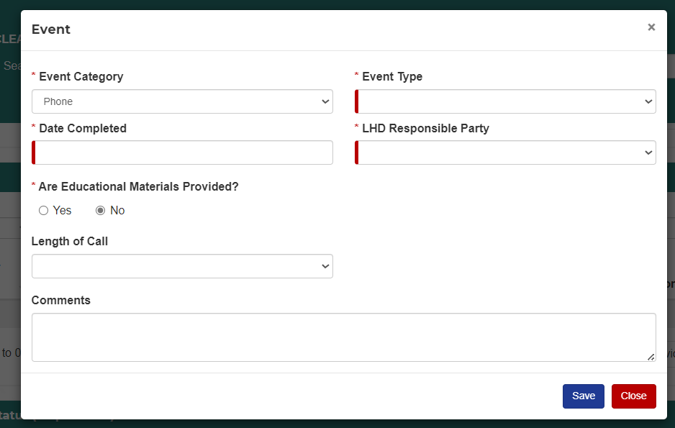
Adding a Letter event
A popup will open with the following fields:
- Event Category - Letter
- Event Type
  - Family Case Closure 3.5
  - Family Confirmatory Venous
  - Family Opted Out NCM
  - Family Unable to Reach
  - Redraw Letter
  - Provider CM Complete
  - Provider CM Declined
  - Provider Unable to Reach
  - Letter Sent to Other – comment required
- Date Completed
- LHD Responsible Party
- Who was the letter sent to – checkboxes, multiple selections can be made. Each selection will create a separate event. The selections are:
  - Parent
  - Provider
  - Medical Health Plan
  - Other – must fill out the specify box
- Are Education Materials Provided?
- Comments
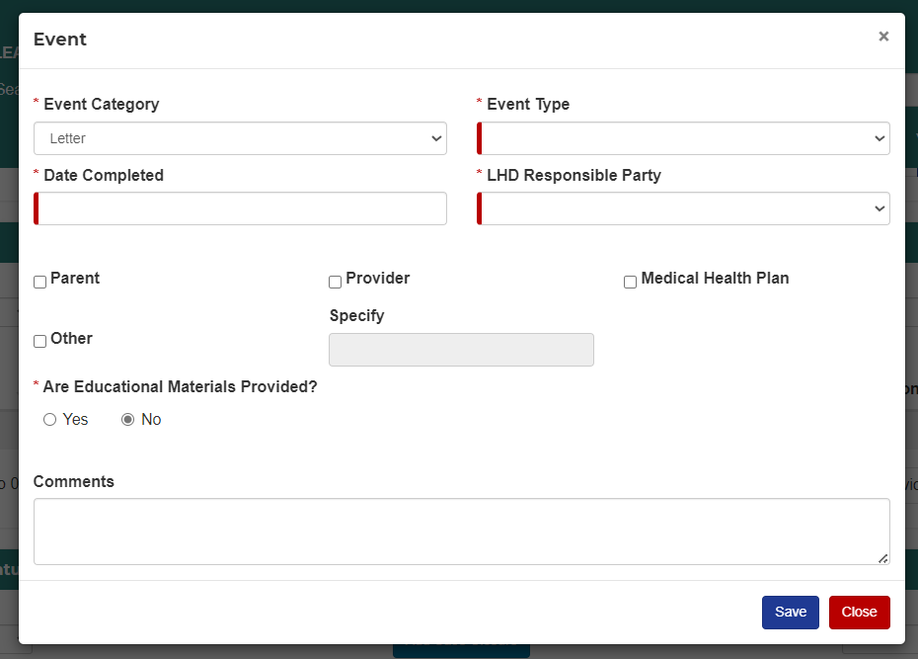
Adding an Interventions/Other event
A popup will open with the following fields:
- Event Category – Interventions/Other
- Event Type
  - Educational Materials Provided
  - Case Review- used when NC or LHD CM review case, but no changes or outreach is performed
  - Care Coordination
  - CPS contacted
- Date Completed
- LHD Responsible Party
- Are Education Materials Provided?
- Comments
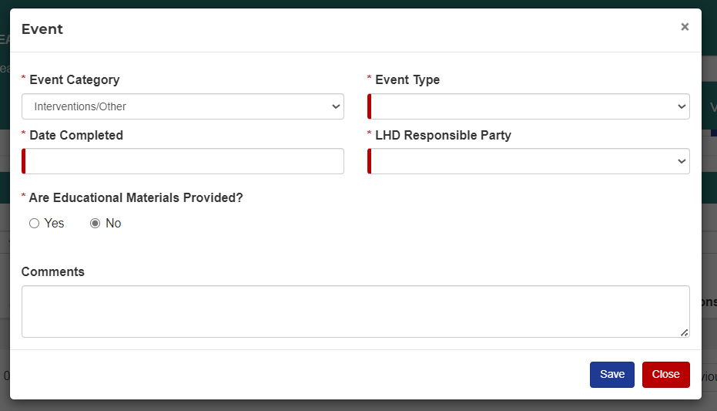
Adding a Referral event
A popup will open with the following fields:
- Event Category - Referral
- Event Type
  - Nutrition
  - Health
  - Child Development
  - Housing
  - Financial Support
  - Insurance
  - Legal
- Date Completed
- LHD Responsible Party
- Are Education Materials Provided?
- Did you offer NCM services? Yes, no
- Did the family accept NCM services? Yes, no
- Referral Subtype: Options change dependent on which event type is selected.
- Referral Date
- Reason for Referral
- Name of Agency
- Contact at Agency
- Comments
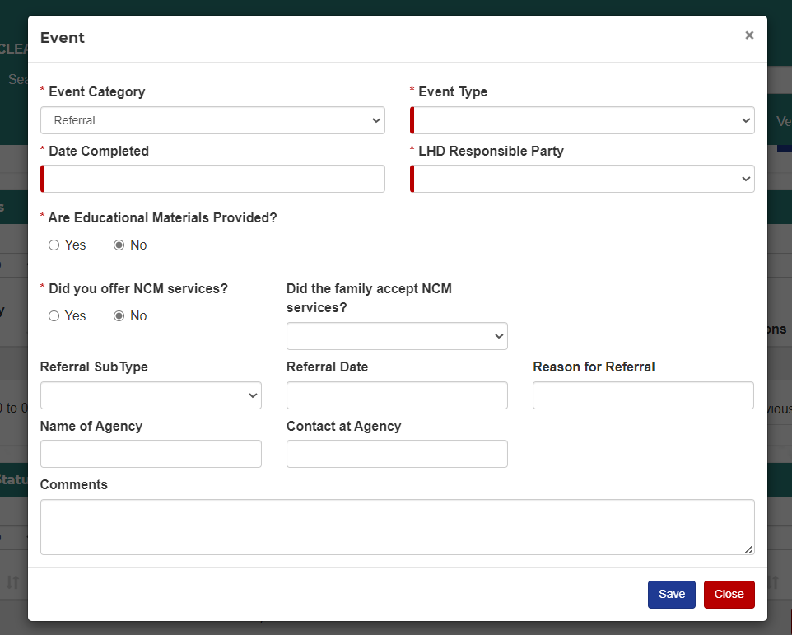
Adding an Email event
A popup will open with the following fields:
- Event Category - Email
- Event Type
  - Family Case Closure 3.5
  - Family Confirmatory Venous
  - Family Opted Out NCM
  - Family Unable to Reach
  - Redraw Letter
  - Provider CM Complete
  - Provider CM Declined
  - Provider Unable to Reach
  - OTHER letter sent – comment required
- Date Completed
- LHD Responsible Party
- Are Education Materials Provided?
- Did the Parent/Guardian respond?
- Did you offer NCM services? Yes, no
- Did the family accept NCM services? Yes, no
- Comments
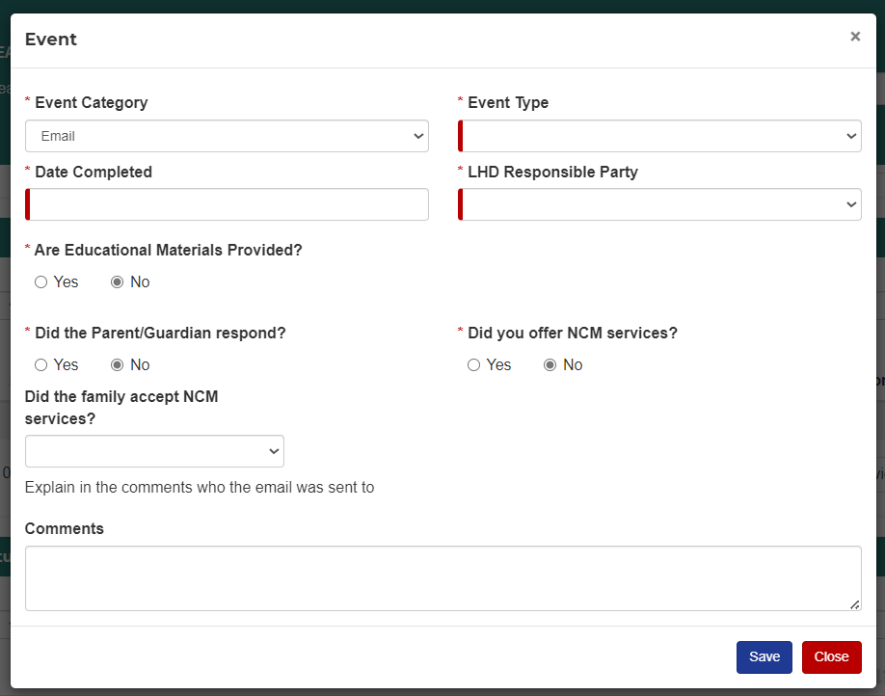
Adding a In Person Contact Attempt event
A popup will open with the following fields:
- Event Category – In Person Contact Attempt
- Event Type – Contact Attempt
- Date Completed
- LHD Responsible Party
- Are Education Materials Provided?
- Length of Conversation – how long was the contact
  - <5 Minutes
  - 5 - 15 minutes
  - 16 – 30 minutes
  - 31- 60 minutes
  - > 1 hour
- Did you offer NCM services? Yes, no
- Did the family accept NCM services? Yes, no
- Comments
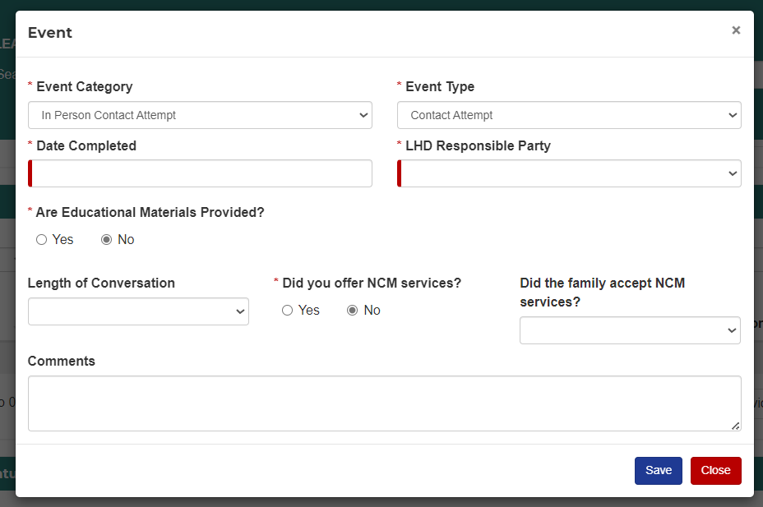

Adding Sticky Notes:
The Sticky Notes section allows a user to leave comments about the patient or case.
When opened, a table will show with the following fields:
- Date – date note was created
- Note – contents of the note
- Uploaded by – who created the note
- Action – Edit, Delete
To add a note, click on the Add Note button in the Sticky Notes tab.
A window will open with a place to add a note. It is limited to 280 characters.
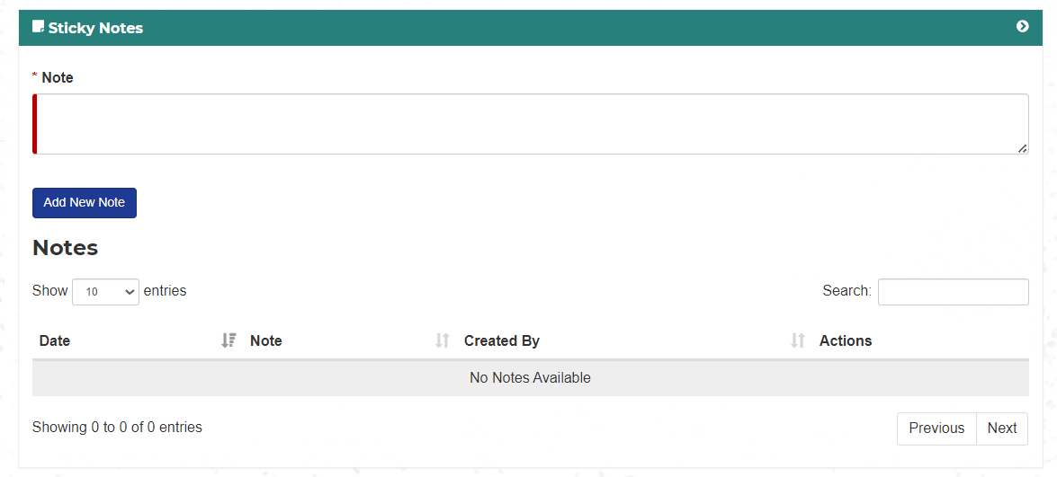

Uploading Files:
To upload a file, click on the Choose File button in the Files tab.
Browse to your file and select it.
Select a subject from the dropdown. The selections are:
- Initial Home Visit
- Follow up Home Visit
- Plan of Care
- Consent
- Environmental Investigation
- CHW Form
- Other

Add a note if desired. If Other is selected as a subject, a Note is required.
Click the Add New File button and the file will be uploaded.
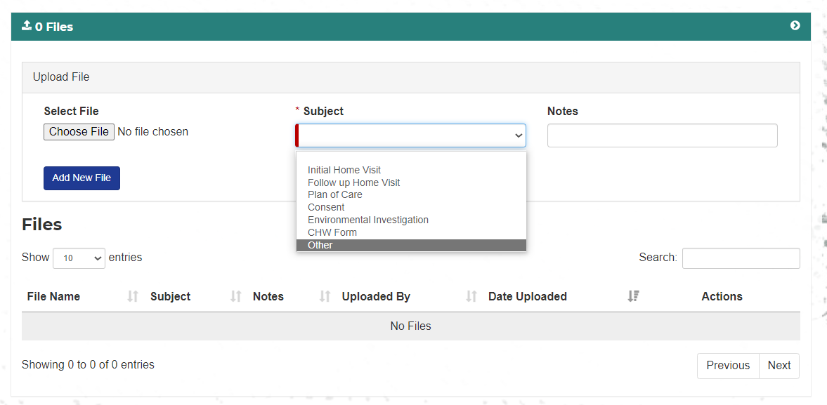
The file will now display in the file table.
Closing Cases
To close a case, click on “Add Case Closure” under Case Status at the bottom of the case details page. Choose reason for closure in drop down options and enter date of closure. If “other” is selected, enter reason/comments.
- If family refused services pick: Case Closed-Refused
- If you are unable to contact the family select: Case Closed- Unable to Contact
- If the child moved out of state select: Case Closed- Moved Out of State
- If you completed the plan of care and the goals are met select: Case Closed- Plan of Care Complete
- If you closed the case because the child's level was below BLRV prior to CM initiation select: Case Closed – Other, specify reason Case Closed- BLL
- FOr any other closure reason select Case Closed- Other and provide a comment explaining why the case was closed

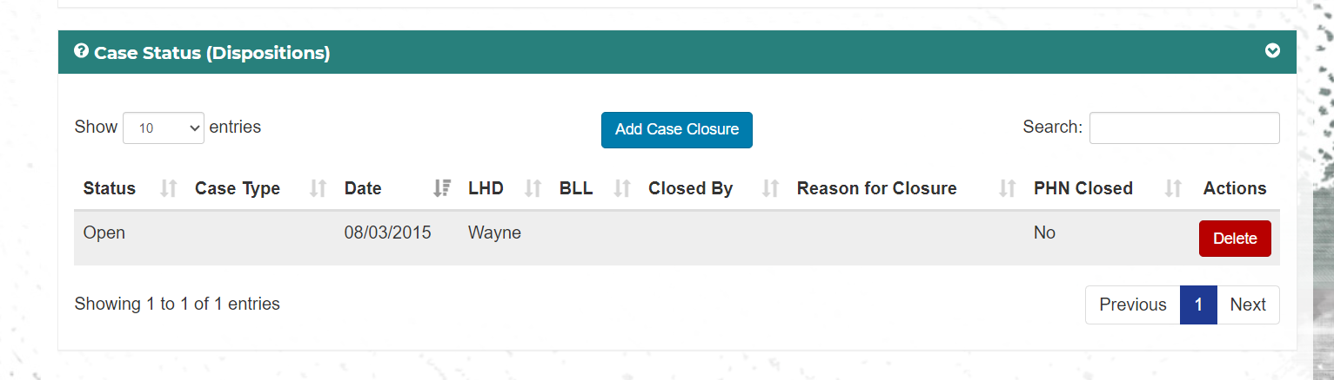
*note – only nurses and supervisors can close cases.

