MDHHS MICLEAR Case Management
Case Management User Guide

Table of Contents
1 - Getting Started: Case Management Overview 4
2 - Accessing Case Management 4
3 – Roles 4
4 – Manage Users 5
4.1 – Adding a User 6
4.2 – Editing a User 7
5 – Account Lockout 8
6 – Home Page 8
6.1 – My Assigned Cases tickler 9
6.2 – Unassigned Cases tickler 9
6.3 – Elevated Patient tickler 10
6.4 – Cases with 60 Days No Activity tickler 10
6.5 – Hospitalized Cases tickler 11
7 – Patient Search 12
7.1 – Patient Search 12
7.2 - Search Results 13
8 – Patient Details 13
8.1 – Patient Details Header 14
8.2 – Patient Details 15
8.3 – Blood Lead Level Test Results 17
8.3.1 – View/Edit Blood Lead Level Result 18
8.3.2 – Add Blood Lead Level Result 19
8.4 – Case Details 21
8.5 – Addresses 22
8.5.1 - View/Edit Address 23
8.5.2 Archive Address 23
8.5.3 – Address Case History 24
8.5.4 - Add Address 24
8.5.5 - Address History 25
8.6 – Family Members 26
8.6.1 – Update Primary Guardian 26
8.6.2 - Add New Family Member 26
8.6.3 - Add New Family Member Who Is An Existing Patient 27
8.6.4 - View/Edit Family Member 29
8.6.5 – Delete Family Member 30
8.7 – Chelations 30
8.7.1 Add Chelation 31
8.7.2 View or Edit a Chelation 31
8.7.3 – Delete a Chelation 32
8.8 – Files 32
8.8.1 - Upload file 32
8.8.2 - Download file 33
8.8.3 - Delete File 33
8.9 – Sticky Notes 34
8.10 - Letters 34
9 – View/Edit Case Details 35
9.1 – Edit Case Details 35
9.2 – Assignment History 36
9.2.1 – Assignees 37
9.2.2 – Case Health Departments 37
9.3 – Events 38
9.3.1 – Add Event 39
9.3.1.1 – Add Home Visit event 39
9.3.1.2 – Add Text event 40
9.3.1.3 – Add Phone event 42
9.3.1.4 – Add Letter event 43
9.3.1.5 – Add Interventions/Other event 45
9.3.1.6 – Add Referral 46
9.3.1.7 – Add Email event 48
9.3.1.8 – Add In Person Contact Attempt 49
9.4 – Case Status (Disposition) 50

1 - Getting Started: Case Management Overview
This document is provided as an instructional guide by the Michigan Department of Health and Human Services (MDHHS) for collecting and recording relevant information on MDHHS MICLEAR patients.

2 - Accessing Case Management
The MICLEAR Case Management application is accessible to users via MiLogin.

3 – Roles
There are 8 roles in the Case Management system. These are assigned to a person when they are created in the system. They can be edited by a Superuser or a Case Management Admin.
- Superuser
    - Able to edit any records
    - Able to delete any record
    - Able to view all data (both Case Management and MICLEAR) - cannot access ELMAH, Hangfire, or Debug Utilities
    - Can delete records
      - Except for test results (alert if delete is needed)
    - Create new users and edit current users
- Case Management Admin
    - Able to view all data in Case Management
    - Able to edit any records
    - Able to delete any records
      - Except for test results (alert if delete is needed)
    - Create new users and edit current users
- MICLEAR Admin
    - (All the same functionality as a super user, but not Case Management)
- Local Case Manager - (includes Clerical Staff)
    - Can't delete any case specific information
    - See only own LHD
    - No Delete
    - Have limited reporting options
- Community Health Worker
    - See only own LHD
    - No Delete
    - Have limited reporting options
- Case Management Read Only -
    - Can view all CM data
    - No edit
    - No delete
    - No ability to run any report.
    - (Some of the people in this role may be auditors)
- MICLEAR Read Only
    - Can view all MICLEAR data
    - No edit
    - No delete
    - No ability to run any report
- MPHI User
  - Reserved for MPHI staff to be able to troubleshoot the application

4 – Manage Users
The Manage Users page is found under the Admin dropdown -> Case Management – Manage Users
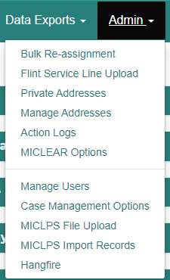
When the page loads, the Manage Users table will load with the following data:
- Username
- First Name
- Last Name
- Email Address
- Role
- LHD – Local Health Department
- Status – Active, Inactive
- Actions – Edit
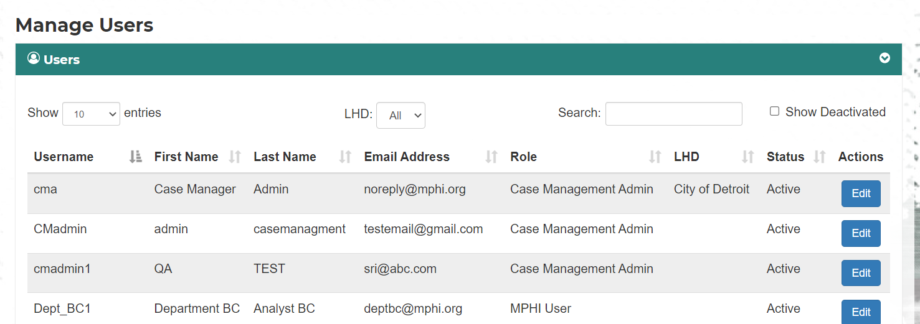

4.1 – Adding a User
The following steps need to be taken to add a user to the Case Management system
- A user will request access to the MICLEAR application via MiLogin.
- An authorized approver will see the request come in via an email notification. The MICLEAR and MICLEAR Case Management teams will need to coordinate with each other on handling requests if they do not recognize the user. Individuals who request access should use their work emails and not their personal emails to request access to the system.
- If there are any questions about that user, the authorized approver should contact them via email or phone number.
- Once the request has been identified, the MICLEAR Case Management user should create an account for them using their MiLogin username in the system and give them the proper user role.
  - If any mistakes are made with the username, the account should be deactivated and they need to start over and create a new account with the correct username.
- Only after creating their account in the MICLEAR Case Management system, the authorized approver should approve their MiLogin request. If they approve them before creating a user account in the MICLEAR Case Management system, the individual will get an error message when trying to access the system.
- The individual will get an email from MiLogin notifying them that their request to the system has been approved.
- Any user that has not logged in the system for over 60 days will be flagged as deactivated and prevented from logging into the system. You can view deactivated users in the system by going to the User Management page and clicking the "Show deactivated" checkbox to list deactivated users as well as active users.
The Admin will enter the following user information:
Fields marked with an Asterisk are required.
- *MiLogin Username
- *First Name
- *Last Name
- *Email Address
- *Phone Number
- Mobile Number
- *Job Title
- LHD – if a role is selected that is restricted to a specific LHD, this field will become required
- *Role
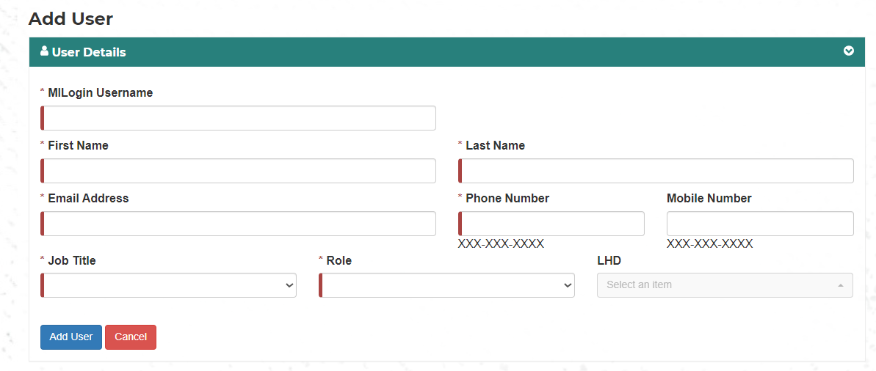

4.2 – Editing a User
To edit a user, click on the Edit button on the far right of the row the user is listed in.
The following fields will display:
Fields marked with an Asterisk are required.
- *MiLogin Username – read only
- *First Name
- *Last Name
- *Email Address
- *Phone Number
- Mobile Number
- *Job Title
- *Role
- LHD – if a role is selected that is restricted to a specific LHD, this field will become required
- Is Active – checkbox, if it is checked the user is active
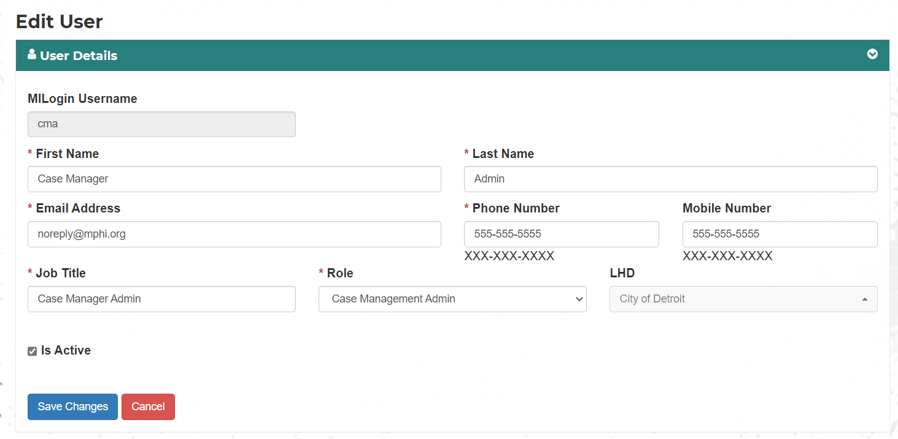
You can edit any field except the MILogin username.
To switch the user from Active to Deactivated, uncheck the Is Active checkbox. If it is unchecked you can check it to make the user Active.
Clicking Save Changes will save any changes made.
Clicking Clear will disregard any changes and take you back to the Manage Users page.

5 – Account Lockout
User is required to log in to the application every 60 days. If the user is locked out of the application an admin must change their status to Active to unlock their account.

6 – Home Page
When a user logs into the application, they are directed to a home page.
The Home Page is where most users will be directed on login. It can also be accessed by clicking the home link or MDHHS image in the navigation bar at the top of the page.
The Home page is designed to help you quickly view and access Case Management information.
It has 5 data tables (called ticklers) that show various information.
- My Assigned Cases
- Unassigned Cases
- Elevated Patient
- Cases With 60 Days No Activity
- Hospitalized Cases

6.1 – My Assigned Cases tickler
This shows all cases that the user has been assigned to. The fields include:
- Patient Name
- Blood Lead Level – most recent blood test result
- Case Open Date
- Specimen Date – date of most recent blood test
- Guardian Name
- Phone Number – guardian phone number
- Actions – View/Edit
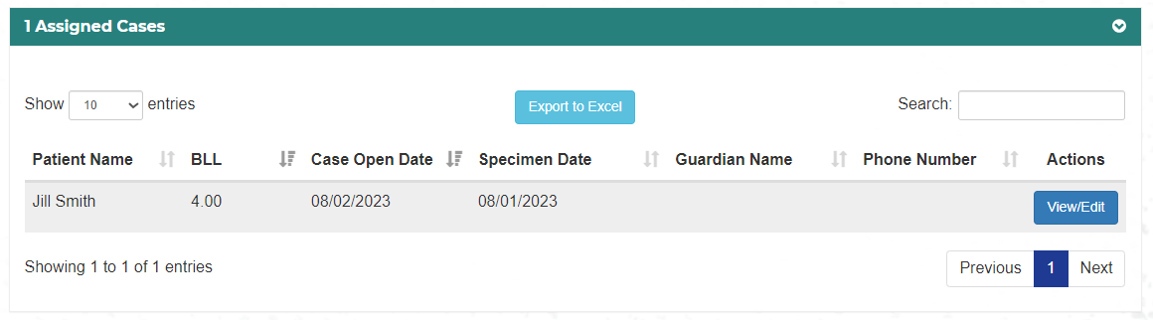

6.2 – Unassigned Cases tickler
This shows all cases in the users LHD that have not had a local case worker assigned to it. The fields include:
- Patient Name
- Blood Lead Level – most recent blood test result
- Case Open Date
- Specimen Date – date of most recent blood test
- Guardian Name
- Phone Number – guardian phone number
- Actions – View/Edit

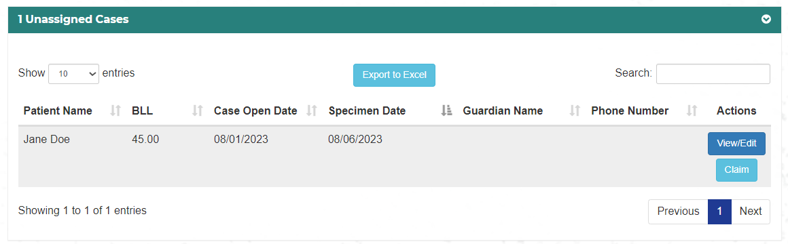

6.3 – Elevated Patient tickler
This shows all cases that have a BLL equal to or higher than the current threshold. The fields include:
- Patient Name
- Blood Lead Level – most recent blood test result
- Specimen Date – date of most recent blood test
- Case Status
- Assigned Case Manager
- Guardian Name
- Phone Number – guardian phone number
- Actions – View/Edit

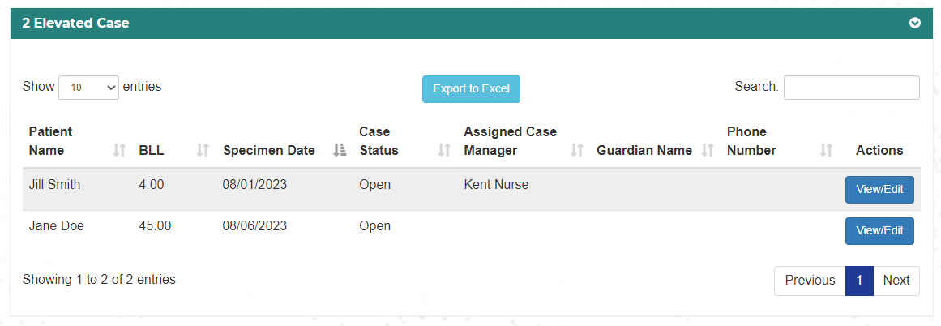

6.4 – Cases with 60 Days No Activity tickler
This shows all cases that have not had a new test result, event, or note in the last 60 days. The fields include:
- Patient Name
- Blood Lead Level – most recent blood test result
- Specimen Date – date of most recent blood test
- Case Status
- Assigned Case Manager
- Guardian Name
- Phone Number – guardian phone number
- Actions – View/Edit
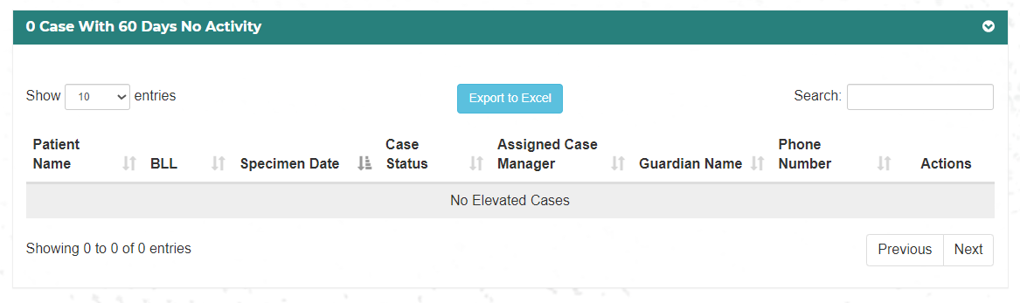

6.5 – Hospitalized Cases tickler
This shows all cases that have a BLL higher than 40. The fields include:
- Patient Name
- Blood Lead Level – most recent blood test result
- Specimen Date – date of most recent blood test
- Assigned Case Manager
- Chelation Start Date
- Guardian Name
- Phone Number – guardian phone number
- Actions – View/Edit
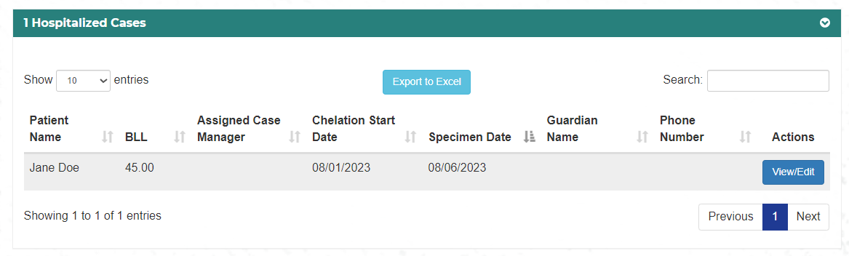

7 – Patient Search
To access the patient search, click Patients on the navigation bar.

7.1 – Patient Search
The Search Patients page will open and you can search for patients using the following fields:
- First Name
- Last Name
- Date of Birth
- Patient ID – Case Management system ID
- Street
- Unit
- City
- Zip
- County
- Case Status – Open, Closed, Not a Case, and Unconfirmed
- LHD – Local Health Department, if user is restricted only available LHD(s) will appear
- HHLPSS ID – legacy ID from the HLPSS system, any records created after 1/2024 will not have this ID
- Result Comparison - This comparison choice is for blood lead levels. You can search for results below a designated level, above a designated level, equal to a designated level, or between a range of levels.
- Blood Lead Level – used to search for a specific blood lead level or the lowest level when searching a range of blood lead levels
- Blood Lead Level Upper – the highest blood lead level when searching a range of levels
- Specimen Start Date – bottom range for specimen entered date
- Specimen End Date – top range for specimen entered date
- Chelation – yes/no, patient who has undergone or is currently undergoing chelation
  - If Chelation is checked but no dates entered show all matches
  - If just Month/Year Start date is filled in show all on and after that date
  - If just Month/Year End date is filled in show all on or before that date
  - If both are filled in show all between those dates
- Month/Year Start Date
- Month/Year End Date

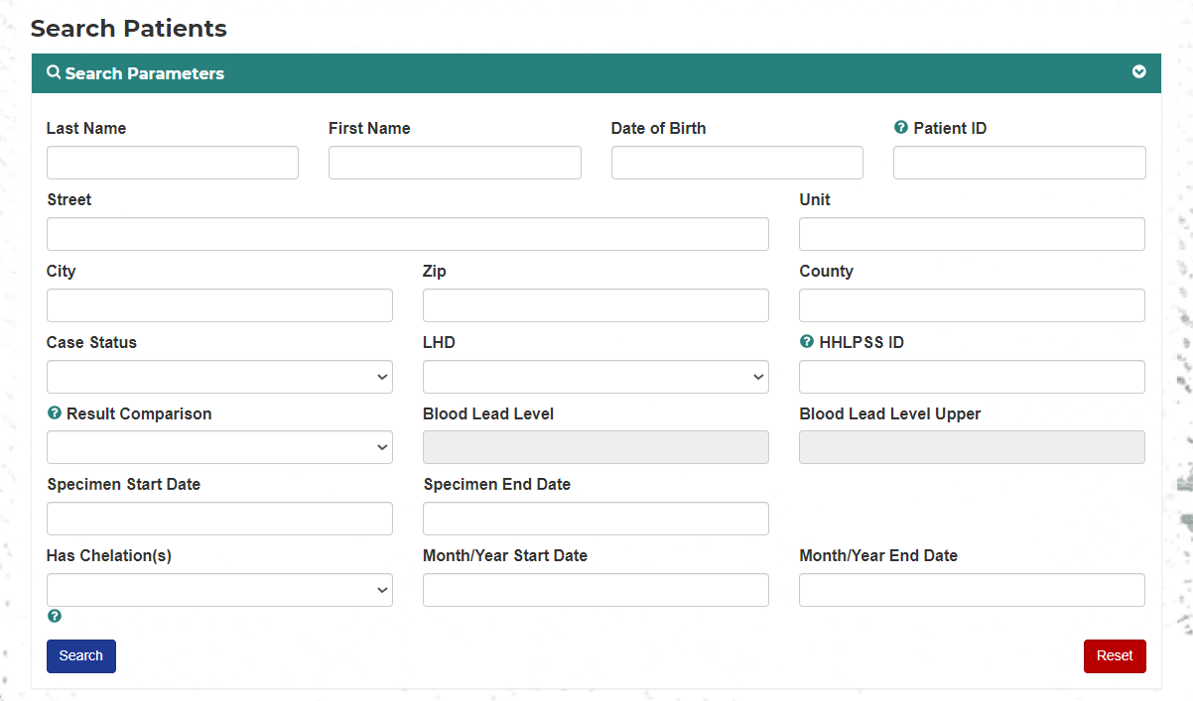
Local Case Managers and Community Health Workers have their searches restricted to the LHD they are assigned to and only results from that LHD will display. If a LHD is selected that they are not assigned to, no results will display.

7.2 - Search Results
The results will be returned in the Patient Search Results table. The following fields will be displayed:
- Name – Last Name First Name
- Address – if address is not verified by the system a Not Verified flag will be displayed
- Date of Birth
- Status – current case status
- LHD – current assigned LHD
- BLL Test Result – most recent result
- Has Chelations – true/false indicates if patient has had or is currently undergoing chelation
- Patient ID - Case Management system ID
- HHLPSS ID - legacy ID from the HLPSS system, any records created after 1/2024 will not have this ID
- Actions – Edit, clicking on this will take you to the patient’s information page
Search results can be exported to Excel by clicking the Export to Excel button.

8 – Patient Details
To view a patient’s details, click on the Edit button in the patient search table. You will be taken to the Edit Patient page.
The Edit Patient page will load and is divided into 9 sections:
- Patient Details
- Blood Lead Level Test Results
- Case Details
- Addresses
- Family Members
- Chelations
- Files
- Notes
- Letters
The arrow on the right side of the section title bar can be used to open or close the section.
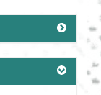
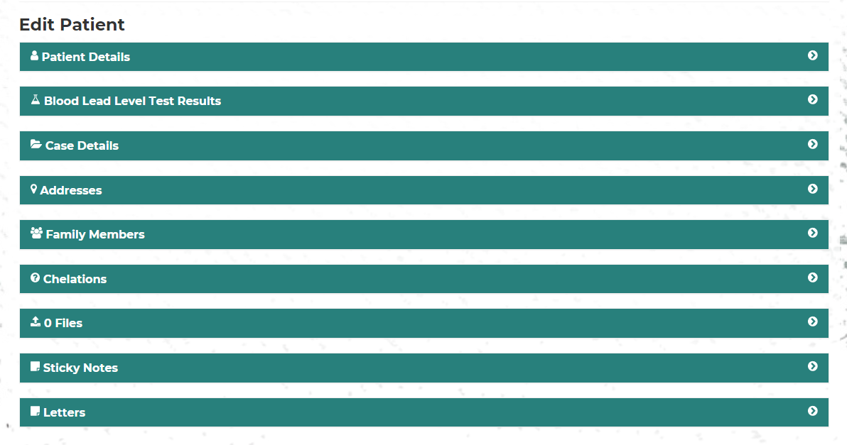

8.1 – Patient Details Header
At the side of the page will be a patient information box, a small blue box with the letter I in it. This is a box with patient information that will stay at the side of the screen as you scroll down the page when you click on it, it will expand and contains the following patient information:
- Name
- Date of Birth
- Patient ID
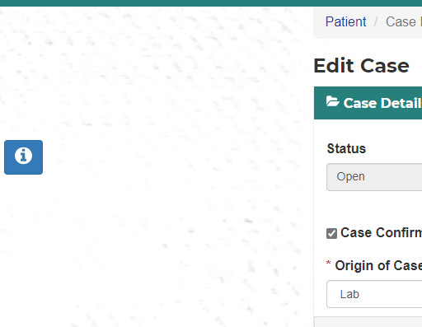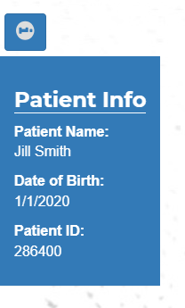
To shrink it back down just click on it again.

8.2 – Patient Details
The Patient Details section allows the user to view or edit the following patient information:
Address and Guardian data is read only and is populated by data from the family member and address sections.
- Last Name
- First Name
- Middle Name
- Patient ID – read only
- Date of Birth
- Age – read only, calculated using date of birth
- Email
- Patient HHLPSS ID
- Sex
- Ethnicity
- Race
- Medicaid ID
  - Eligible – checkbox, if the last check came back eligible this will be checked
  - Update button – this will query Health Plan Benefits to see if the patient is eligible in the current month
  - Date of Last Check – shows when the patient was last checked for eligibility
  - Health Plan Name
  - PCP Name – Primary Provider name
- Street Name – read only
- Apartment or Suite – read only
- City – read only
- Zip Code – read only
- Skip Validation – checkbox, indicates if the address was validated by the system – read only
- County – read only
- Move In Date – Date patient moved into the address– read only
- Rental – checkbox, indicates if the address is a rental – read only
- Guardian First Name – read only
- Guardian Last Name – read only
- Guardian Phone – read only
- Guardian Email– read only
If a change is made to a field, click the Save Changes button to save the changes or the Cancel button to go back to the Patient Search page.
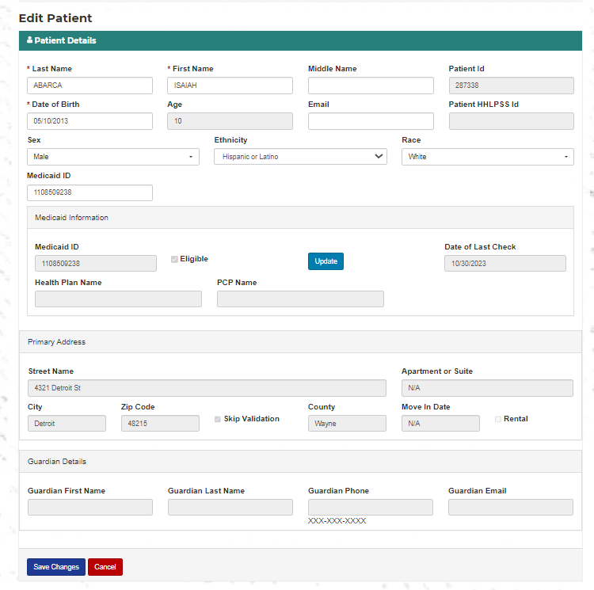

8.3 – Blood Lead Level Test Results
The Blood Lead Level Test Results section is a record of all the patient’s blood tests in the system. The majority of these blood tests are imported from MICLPS, but it also allows a user to enter a new result.
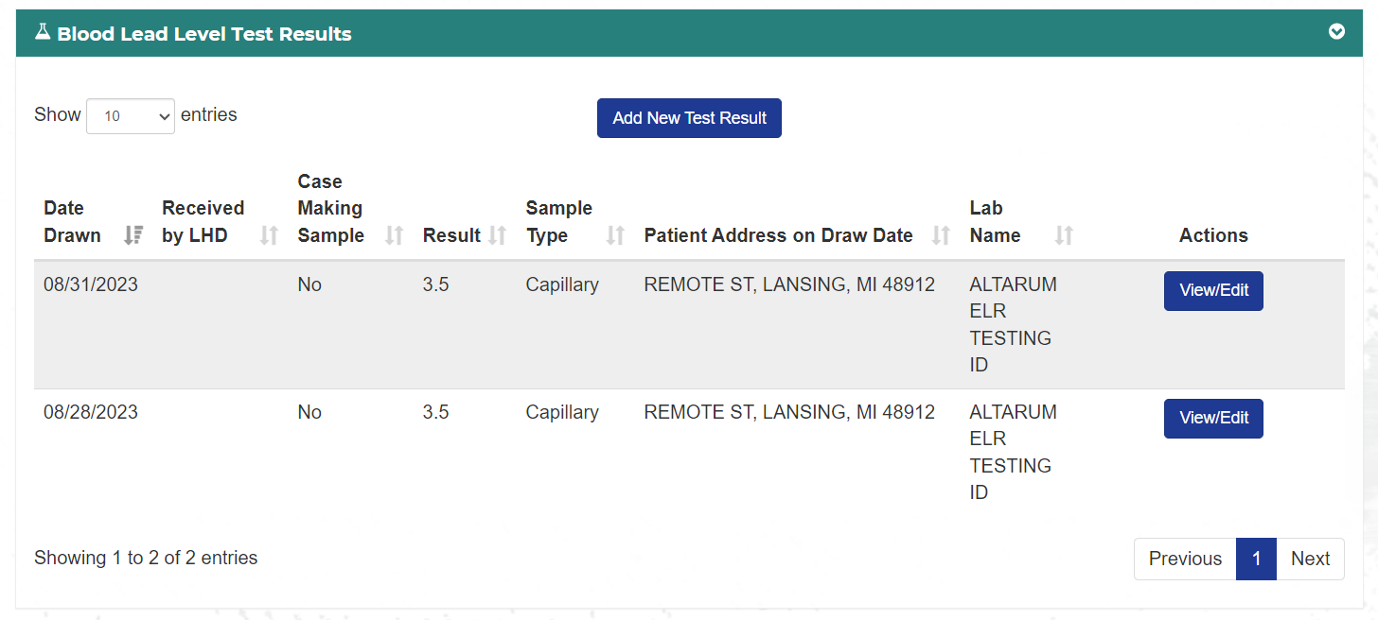

8.3.1 – View/Edit Blood Lead Level Result
To view or edit a blood sample click on the View/Edit button that is in the same row as the sample to be edited. This will open a new page with the following fields:
- Date Drawn - Required
- Date Analyzed
- Date Received by LHD
- Age at Draw – read only, calculated using Date Drawn and Date of Birth
- Pregnant – checkbox, check if patient is pregnant
- Test Result
- Sample Type – Venous, Capillary, Unknown
- Case Making Sample – check box
- Confirmatory Test – check box
- Patient Address on Draw Date
- Institution Name
- Institution Phone
- Institution Address
- Analyzing Laboratory
- Laboratory Phone
- Laboratory Address
- Physician
- MICLPS Serial Number
- Comments
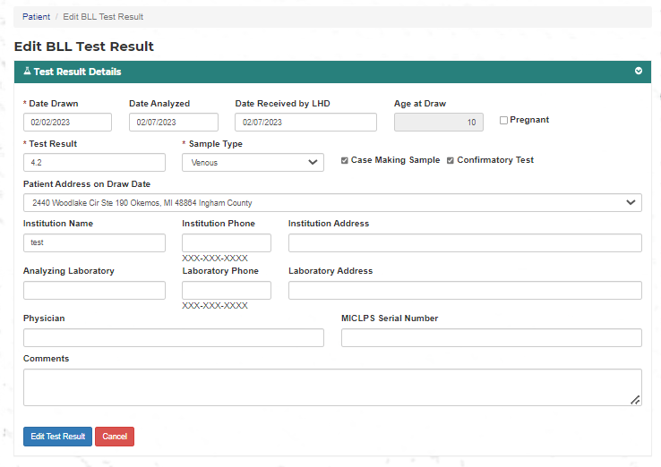
To save any changes made, click the Edit Test Result button.
To remove any changes, click the Cancel button. A popup will display asking for confirmation.
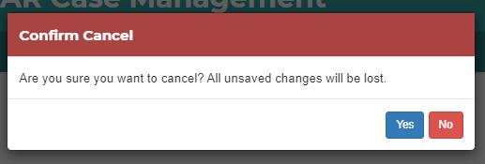

8.3.2 – Add Blood Lead Level Result
Only a MICLPS CLPPP Admin can add a Blood Lead Level Result.
To add a blood test result click on the Add New Test Result button at the top of the table. This will open a new page with the following fields:
- Date Drawn - Required
- Date Analyzed
- Date Received by LHD
- Age at Draw – read only, calculated using Date Drawn and Date of Birth
- Pregnant – checkbox, check if patient is pregnant
- Test Result
- Sample Type – Venous, Capillary, Unknown
- Case Making Sample -
- Confirmatory Test -
- Patient Address on Draw Date
- Institution Name
- Institution Phone
- Institution Address
- Analyzing Laboratory
- Laboratory Phone
- Laboratory Address
- Physician
- MICLPS Serial Number
- Comments
To save the result, click the Add Test Result button.
To cancel the result, click the Cancel button.
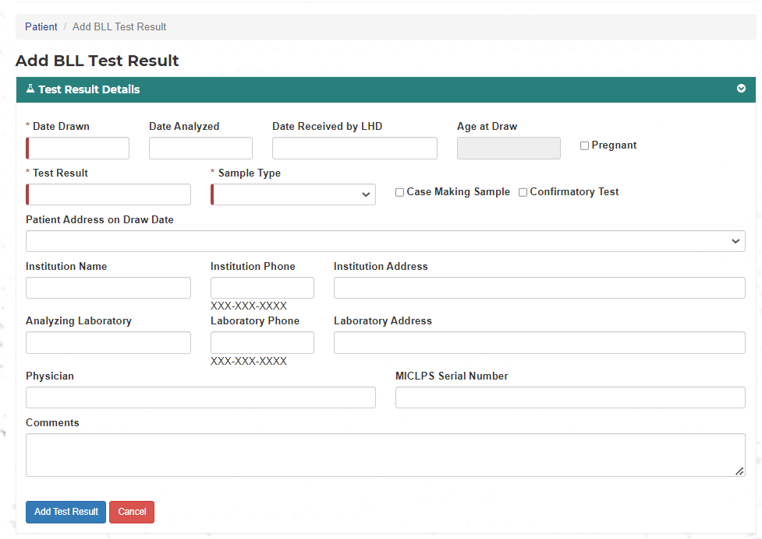

8.4 – Case Details
The Case Details section shows the Case Status and the Case Manager. It will also show the last event entered and the date of the event.
If no case has been created an Add Case button will show. To add a case to the patient, click the button.
**Manual creation of a case will be a very rare occurrence and only a MDHHS CLPPP Admin can add one.
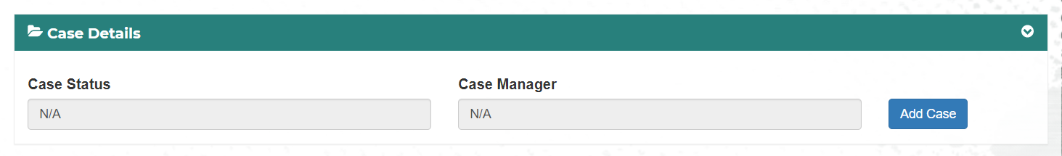
If a case has been created a View/Edit Case button will show, click the View/Edit Case button to view or edit the case.
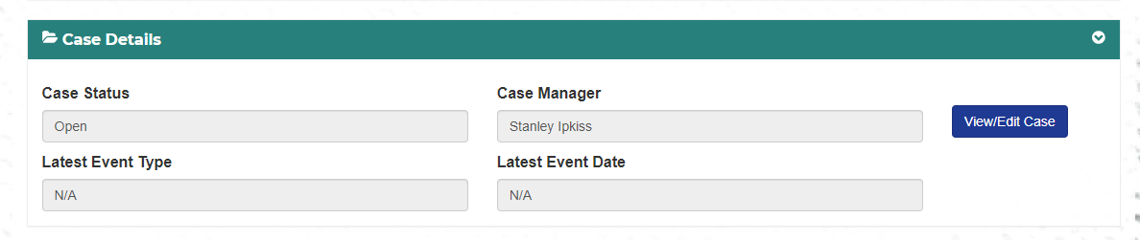

8.5 – Addresses
The address section allows the user to record all current and past addresses of the patient.
It has a table with the following fields:
- Primary – radio button, indicates that this is the patients primary address
- Street
- Unit
- City
- Zip
- County
- CLC/MDC - Childhood Lead Prevention Communities/Minor Civil Division code
- Addtl Cases – this indicates if additional cases, other than the current patient, are tied to this address
- Actions – View/Edit, Archive, Case History
To View/Edit an address, click the View/Edit button
To add an address, click the Add New Address button.
To view all addresses that have been associated with this patient, not just the currently active ones, click the Address History button.
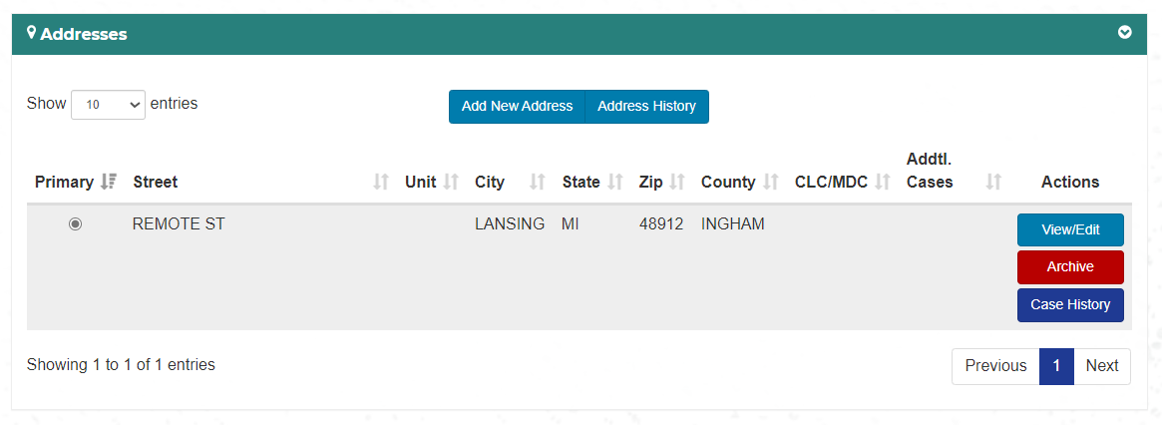

8.5.1 - View/Edit Address
To edit or view an address from the table, find the address row you want to review and click the View/Edit button in that row. A window will open with the following fields:
- Street
- Apt or Suite
- City
- State
- Zip Code
- Country
- Skip Validation – checkbox, only usable if the address will not auto validate.
- County
- Move in Date – date the patient moved into the address
- Is Rental – checkbox, indicate if the address is a rental
- Notes
To save the address click the Save button.
To exit without saving, click the Close button.
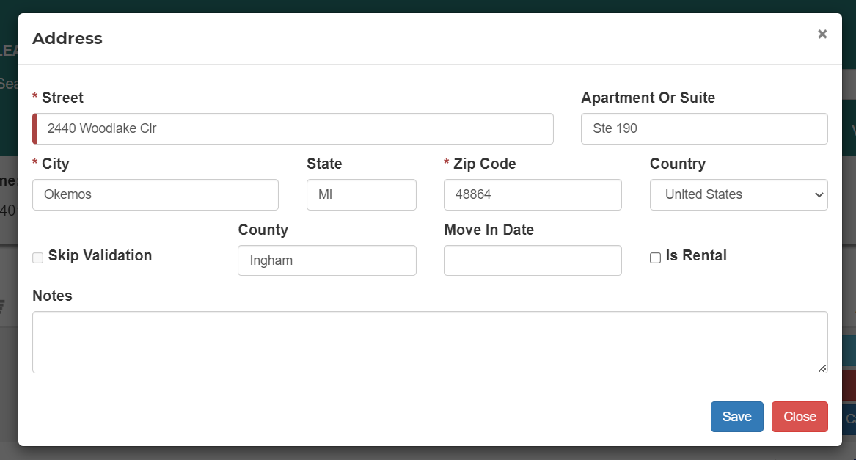

8.5.2 Archive Address
To archive an address from the table, find the address row you want to archive and click the Archive button in that row. A message will open asking if you are sure you want to archive the address. Click Yes to archive the address.
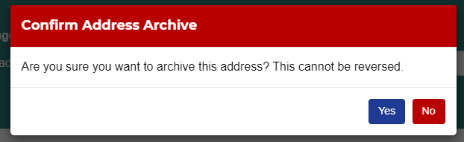
Archived addresses will show in the Address History table.

8.5.3 – Address Case History
To view all cases that are associated with an address, click the Case History button. A window will open with the following fields:
- Patient Name
- Patient ID
- Case Open Date
- Case Making EBL Value
- Case Status
The table can be exported to Excel by clicking the Export to Excel button.

8.5.4 - Add Address
To add a new address to the patient, click the Add New Address button above the table. A window will open with the following fields:
- Street
- Apt or Suite
- City
- State
- Zip Code
- Country
- Skip Validation – checkbox, only usable if the address will not auto validate.
- County
- Move in Date – date the patient moved into the address
- Is Rental – checkbox, indicate if the address is a rental
- Notes
To save the address click the Save button.
To exit without saving, click the Close button.

8.5.5 - Address History
To view the address history of a patient, click the Address History button above the table. A list of all addresses that have been associated with the patient will open with the following fields:
- Address
- Application Status
- Move in Date
- Investigation Date
- Clearance Date
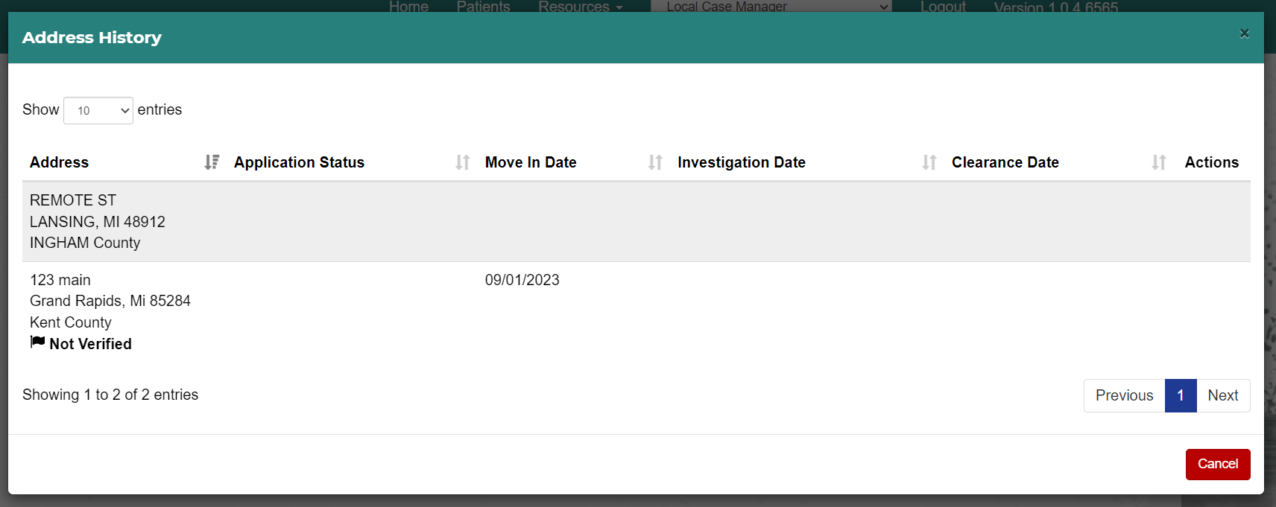

8.6 – Family Members
The Family Members section allows the user to record all known associations of the patient.
It has a table with the following fields:
- Primary Guardian – radio button, if this family member is the primary guardian check this box
- First Name – first name of family member
- Last name – last name of family member
- Age – age of family member
- Relationship to Applicant – how the family member is related to the patient
- Existing Patient – is this family member an existing Case Management patient
- Pregnant – is this patient pregnant
- Actions – View/Edit the patient
To add a new association, click the Add New Family Member button
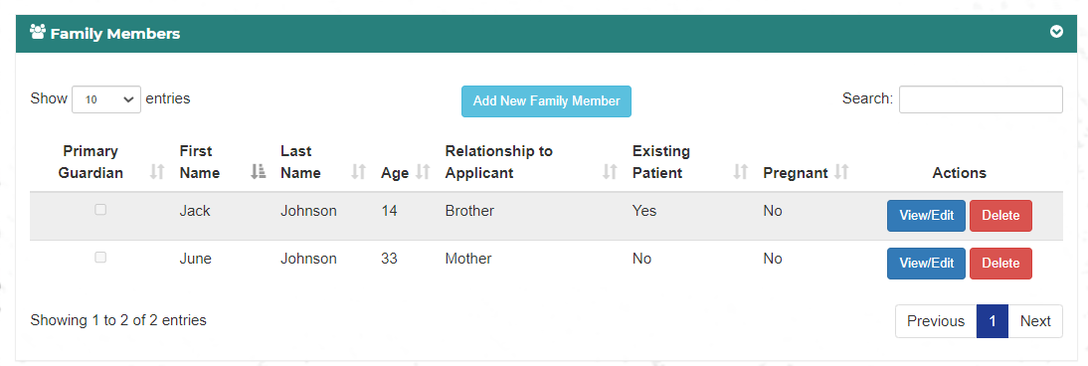

8.6.1 – Update Primary Guardian
To update the primary guardian, click the radio button on the left side of the table next to the person who will be designated as the primary guardian.
Only one primary guardian can be assigned at any time.
If a person (Person 1) was designated as primary guardian, and a new primary guardian (Person 2) is selected, then Person 1 is no longer the primary guardian.

8.6.2 - Add New Family Member
To add a family member to the patient record click the Add New Family Member button.
A page will open for you to input the family member’s information.
At the top of the page it will ask: Is the New Family Member also an Existing patient?
If the answer is yes, see Section 8.6.2.
If the answer is no, continue inputting the following family member information:
- First Name - required
- Middle Name
- Last Name - required
- Date of Birth
- Age
- Street Name
- Apartment or Suite
- City
- State
- Zip Code
- County
- Skip Validation – checkbox, if address does not validate, you can click this to skip validation
- Race
- Ethnicity
- Sex
- Email
- Phone Number
- Alternate Phone Number
- Patient’s relationship to new Family Member
- Family Member’s relationship to Patient
Click Save to save the new family member, you will be returned to the Family Member section and the new member will now appear in the table.
Click Cancel to return to Family Member section

8.6.3 - Add New Family Member Who Is An Existing Patient
At the top of the modal it will ask: Is the New Family Member also an Existing patient? This will help identify connected siblings.
If the answer is Yes, a search table will display. You can enter any combination of Patient ID, First Name, and Last Name for the search.
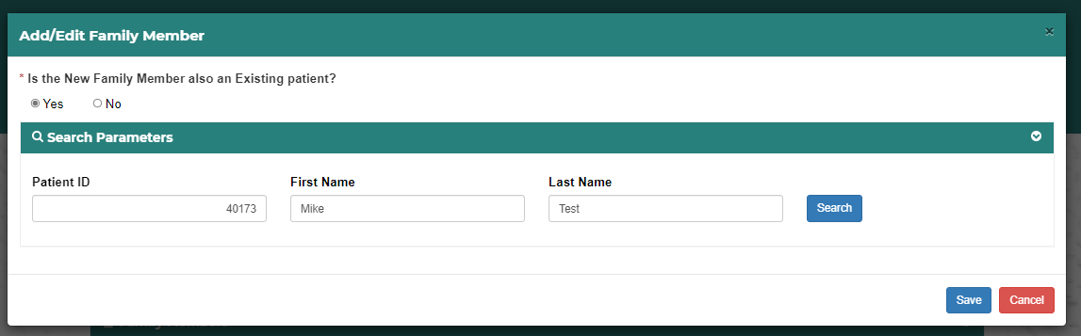
Any matching results will be returned in a table displaying the following fields:
- First Name
- Last Name
- Date of Birth
- Patient ID
- Associate
To associate one of the patients returned in the results, click the Associate button.
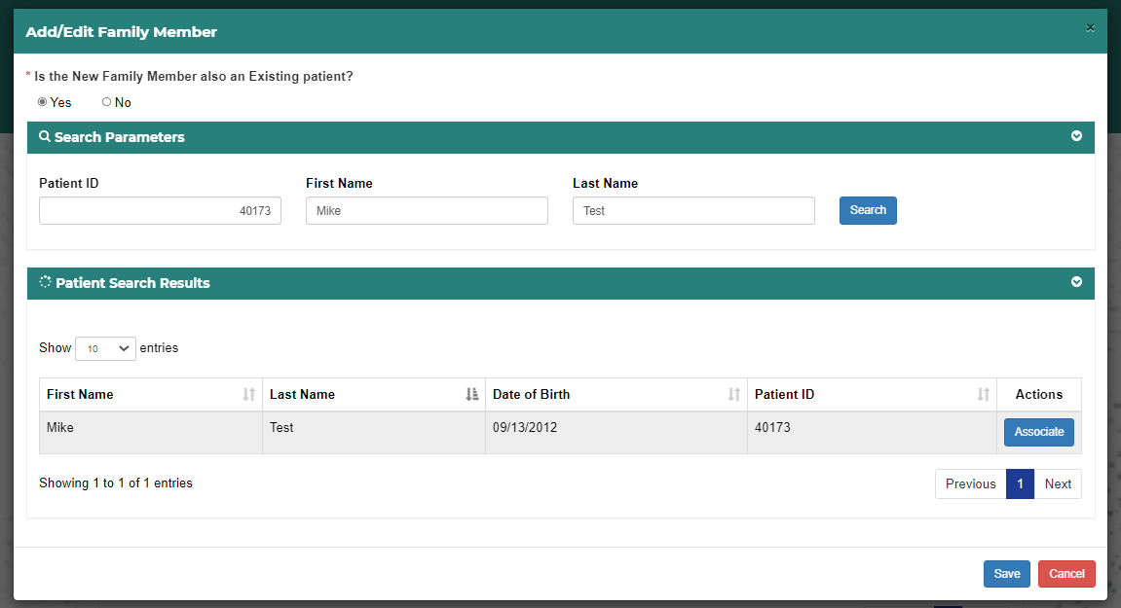
When selected the following message will appear.
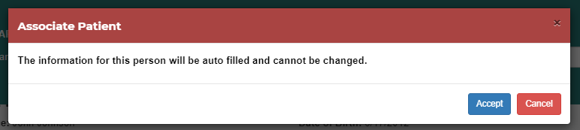
Click Accept to continue associating them with the patient.
Click Cancel to return to the Family Member section.
When the association is accepted most of the data fields will be filled in automatically and cannot be changed.
The Relationship fields will need to be completed to finish associating this person with the patient.
When they have been filled out, click Save to complete the association and return to the Family Member section.
Click Cancel to stop the association and return to the Family Member section.
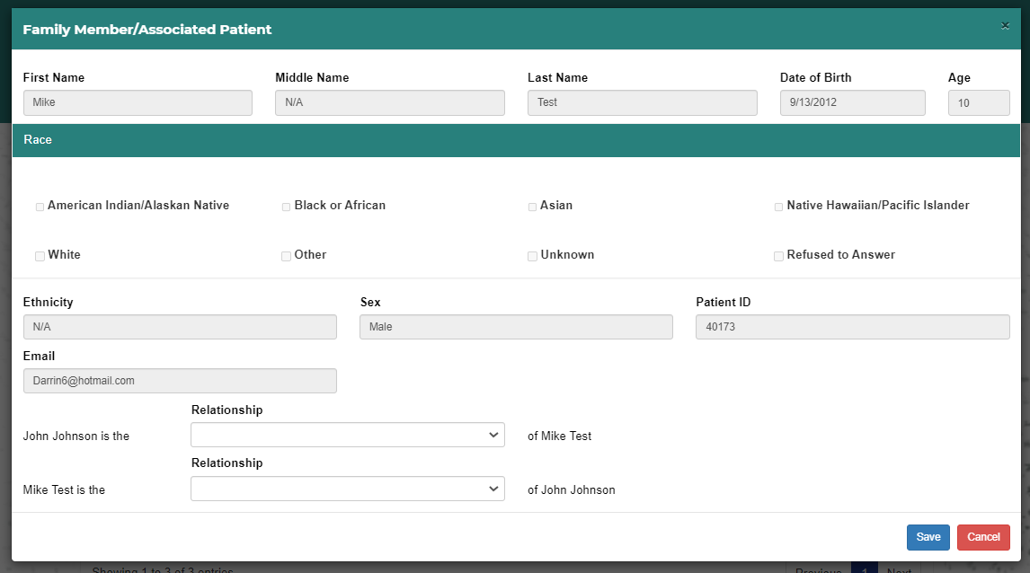

8.6.4 - View/Edit Family Member
To edit a family member click the View/Edit button in the row of the family member.
A page will open for you to edit the family member’s information.
- First Name - required
- Middle Name
- Last Name - required
- Date of Birth
- Age
- Street Name
- Apartment or Suite
- City
- State
- Zip Code
- County
- Skip Validation – checkbox, if address does not validate, you can click this to skip validation
- Race
- Ethnicity
- Sex
- Email
- Phone Number
- Alternate Phone Number
- Patient’s relationship to new Family Member
- Family Member’s relationship to Patient
Click Save to save the edited family member, you will be returned to the Family Member section.
Click Cancel to return to Family Member section.

8.7 – Chelations
The Chelation section shows a history of all Chelation treatments.
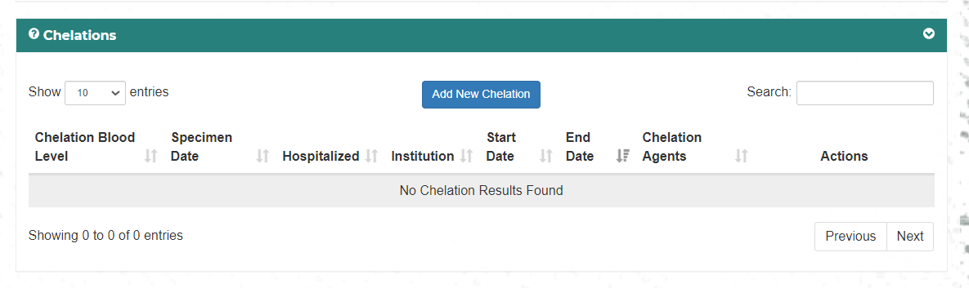

8.7.1 Add Chelation
To add a Chelation click the Add Chelation button. A popup will display with the following fields:
- Start Date
- End Date
- Chelation Blood Level
- Chelating Agent(s) – checkbox, check all that apply
- Specimen Date
- Institution – where the chelation was administered
- Physician
- Was Case Hospitalized for Chelation? – Y/N

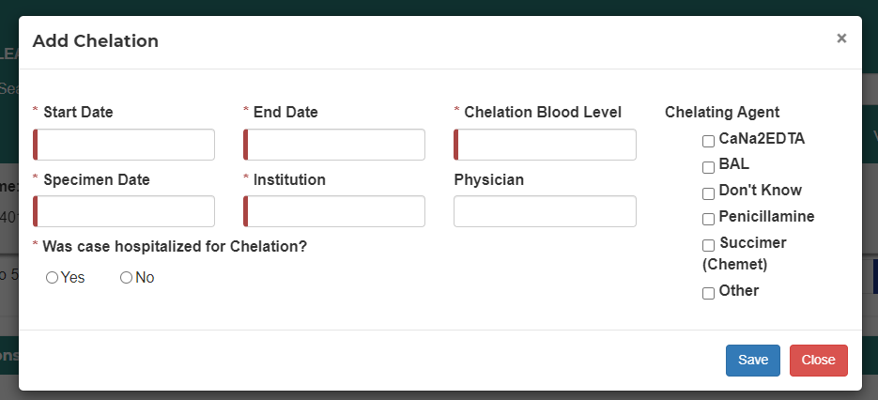

8.7.2 View or Edit a Chelation
To view or edit a Chelation click the View/Edit Chelation button in the table. A popup will display with the following fields:
- Start Date
- End Date
- Chelation Blood Level
- Chelating Agent(s) – checkbox, check all that apply
- Specimen Date
- Institution - where the chelation was administered
- Physician
- Was Case Hospitalized for Chelation? – Y/N

8.8 – Files
To view the file section, if it is not open, click the arrow on the right side of the ribbon.
An Upload File section and a table showing all files uploaded for this patient will display.
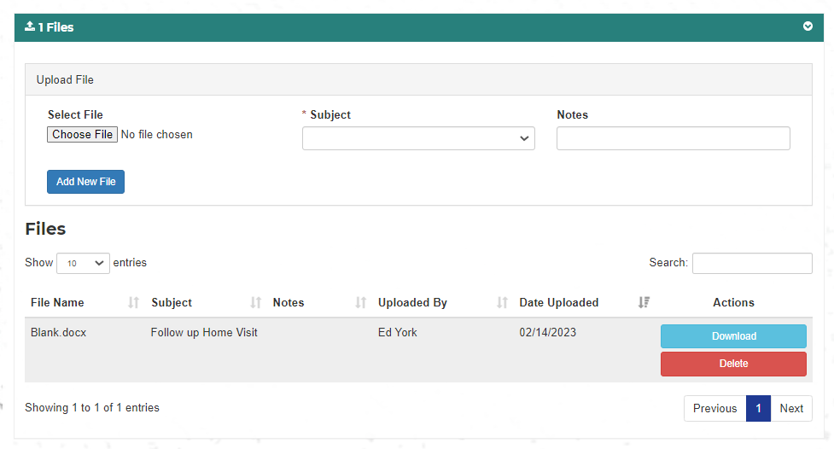

8.8.1 - Upload file
To upload a file, click on the Choose File button.
Browse to your file and select it.
Select a subject from the dropdown. The selections are:
- Initial Home Visit
- Follow up Home Visit
- Plan of Care
- Consent
- Environmental Investigation
- CHW Form
- Other

Add a note if desired. If Other is selected as a subject, a Note is required.
Click the Add New File button and the file will be uploaded.
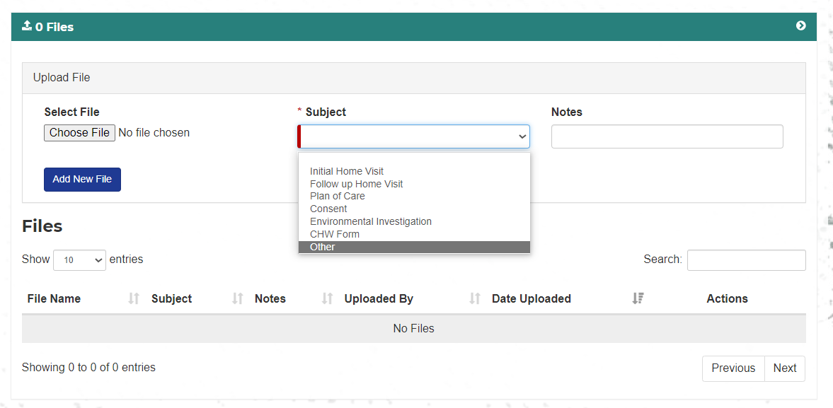
The file will now display in the file table.

8.8.2 - Download file
To download a file, click the Download button in the row the file you want to download is displayed.

8.9 – Sticky Notes
The Notes section allows a user to leave comments about the patient or case.
When opened, a table will show with the following fields:
- Date – date note was created
- Note – contents of the note
- Uploaded by – who created the note
- Action – Edit
To add a note, click on the Add Note button.
A window will open with a place to add a note. It is limited to 280 characters.
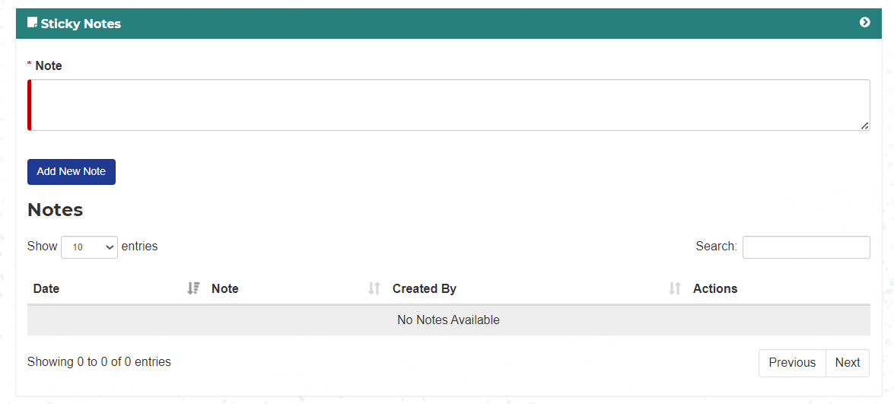

8.10 - Letters
This section will be added at a later date.

9 – View/Edit Case Details
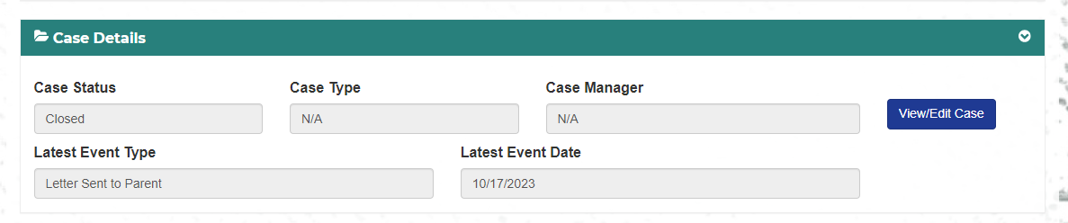
When a user clicks the View/Edit Case button on the patient page, a new page will open showing the following sections:
- Case Details – main case details
- Assignments = who is assigned to the case and what LHD(s) are assigned
- Events – list of all events
- Home Visits/Case Forms – all visit and forms (entered or uploaded)
- Case Status -
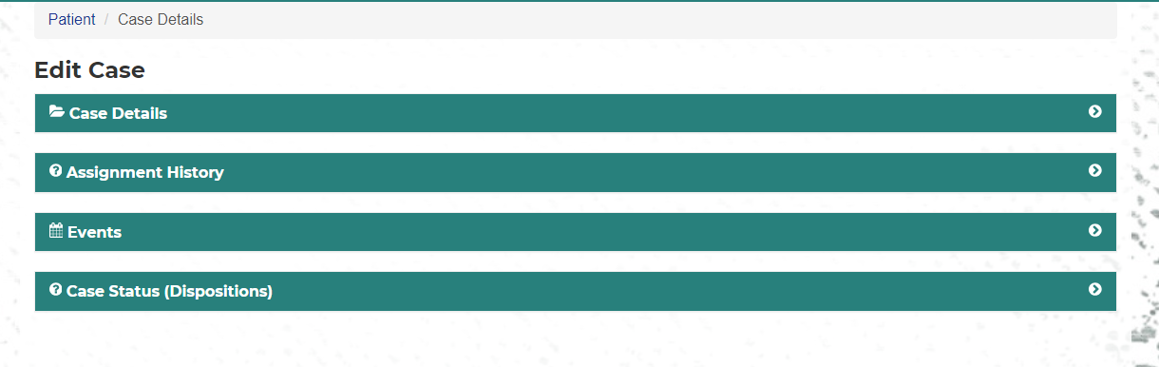

9.1 – Edit Case Details
The Case Details section show the current information on the case. It has the following fields:
Status – case status; these are Open, Unconfirmed, Not A Case, and Closed
Case Manager – manager assigned to the case
Origin of Case Notification – Lab, Provider, State, Transfer from Other Health Department, Other
If transfer from Where – if the case is transferred from another LHD, enter the LHD
Other – if other is selected enter in the details
BLL Test Date date – date of most current blood test
BLL Level – lead level of most current blood test
Sample Type – Venous, Capillary
Patient Address on Draw Date
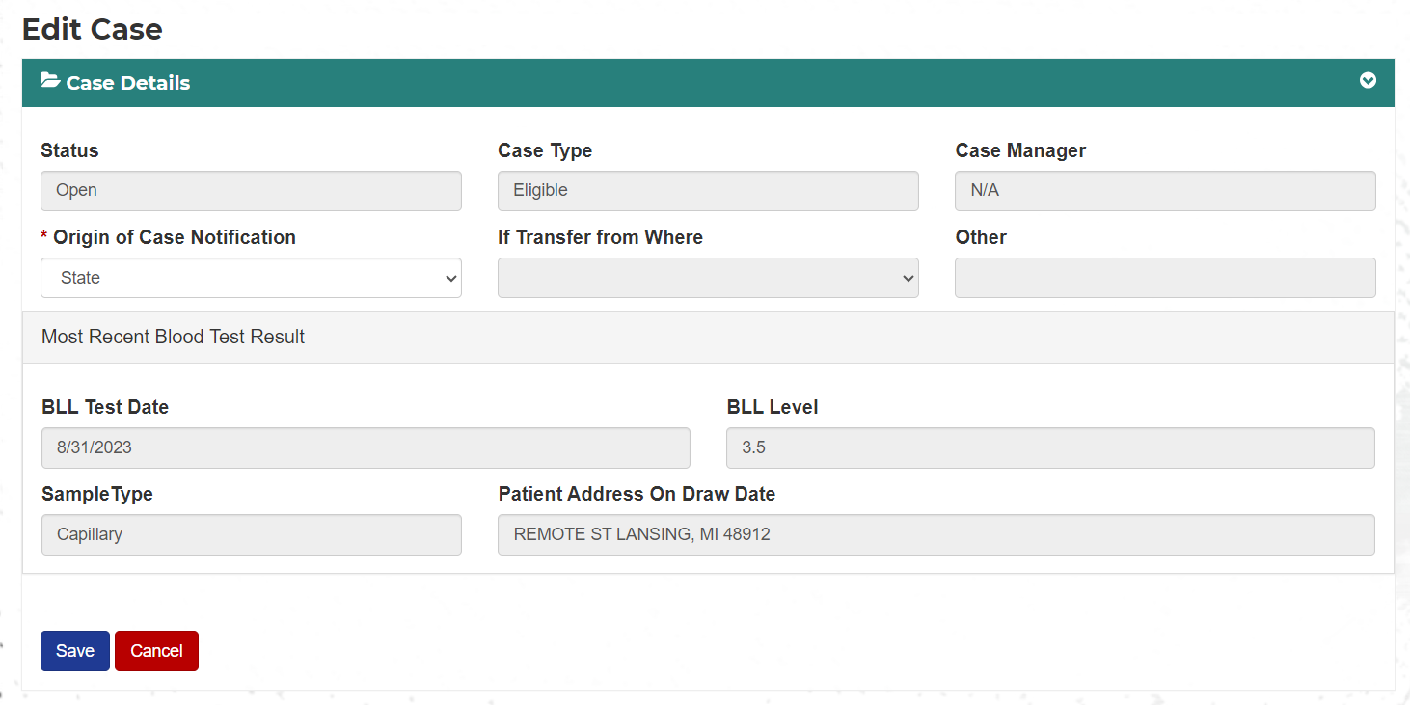

9.2 – Assignment History
When the Assignment History tab is opened the user will see an Assignee table and a section for Case Health Departments.
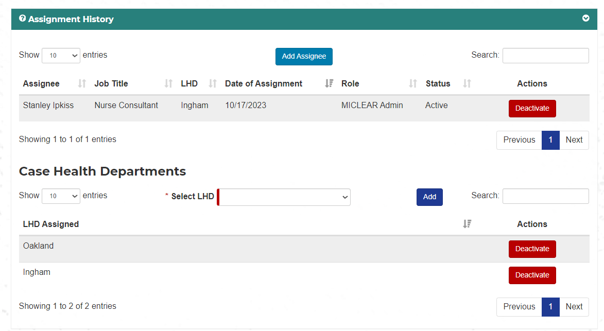

9.2.1 – Assignees
The Assignee table shows all the personnel that have been assigned to the case and displays the following columns:
- Assignee
- Job Title
- LHD
- Date of Assignment
- Role
- Status
- Actions
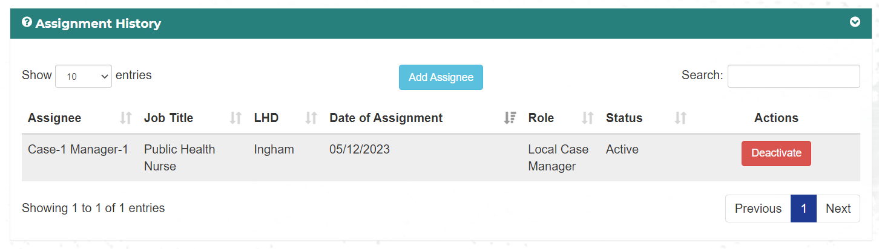
To add a person to the case click the Add Assignee button.
A window will open with the following fields:
- LHD – auto filled for Local Case Managers and Home Visitors with the LHD they work for
- Assignee – A list of people who work for the chosen LHD
- Date Assigned – defaulted to today’s date but can be edited
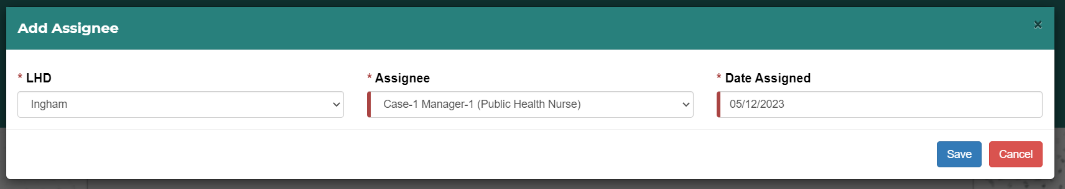
Click Save to assign the person to the case. The assigned person will now appear in the table.
Click Cancel to exit the window without saving.

9.2.2 – Case Health Departments
The Case Health Departments shows all LHDs that are assigned to the case.
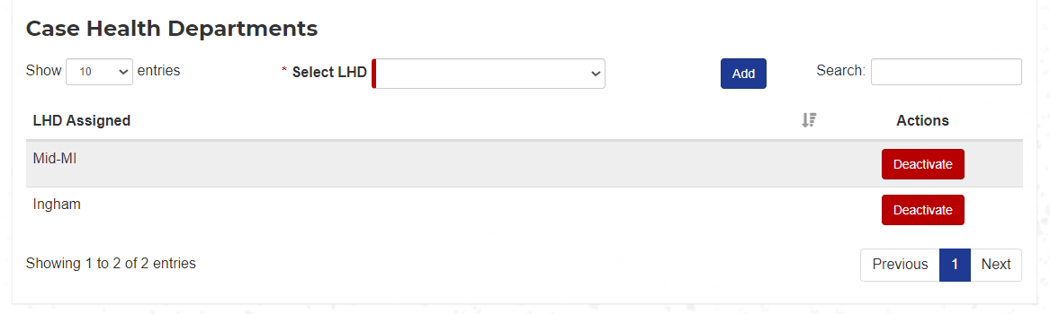
To add a LHD select a LHD from the Select LHD dropdown and click the Add button.
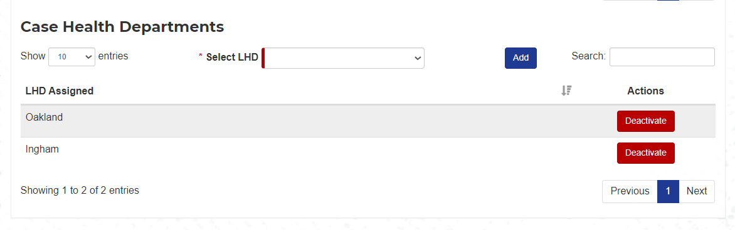
To Deactivate a LHD click the Deactivate button that is on the same row of the LHD you want to Deactivate.

9.3 – Events
The Events section shows a history of all events related to the patient and allows the user to add events. When the section opens a table will show with the following fields:
- Category Type
  - Home Visit
  - Text
  - Phone
  - Letter
  - Interventions/Other
  - Referral
  - Email
  - In Person Contact Attempt
- Event Type – will vary depending on event category selection
- Event Date – date event happened
- Responsible Party – LHD person who made the visit, phone call, letter, etc.
- Medicaid Reimbursable – is this event reimbursable by Medicaid
- Did the family accept or reject NCM service?
- Actions – Edit
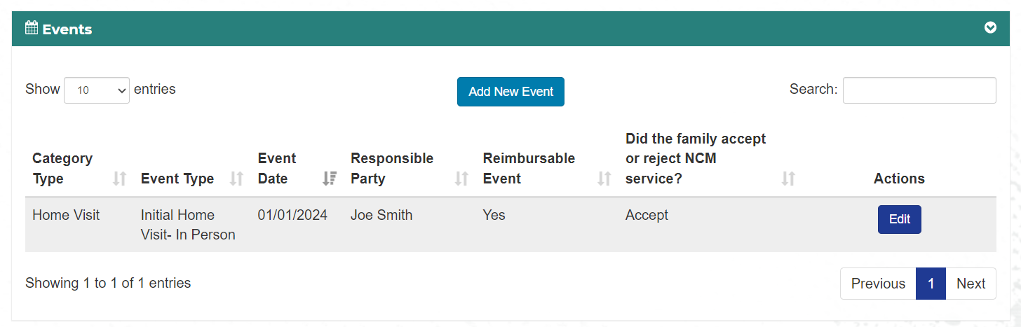

9.3.1 – Add Event
To add and Event click on the Add New Event button.
When you select an Event Category a popup will open specific to that selection. The selections are:
- Home Visit
- Text
- Phone
- Letter
- Interventions/Other
- Referral
- Email
- In Person Contact Attempt

9.3.1.1 – Add Home Visit event
A popup will open with the following fields:
- Event Category – Home Visit
- Event Type
  - Initial Home Visit – In Person
  - Initial Home Visit - Phone
  - Follow Up HV – In Person
  - Follow Up HV - Phone
- Date Completed
- LHD Responsible Party
- Are Education Materials Provided – yes, no
- Length of Conversation – how long was the visit
  - Unanswered/Not home
  - <5 Minutes
  - 5 - 15 minutes
  - 16 – 30 minutes
  - 31- 60 minutes
  - > 1 hour
- Did you offer NCM services? Yes, no
- Did the family accept NCM services? Yes, no, unknown/unresponsive
- Comments
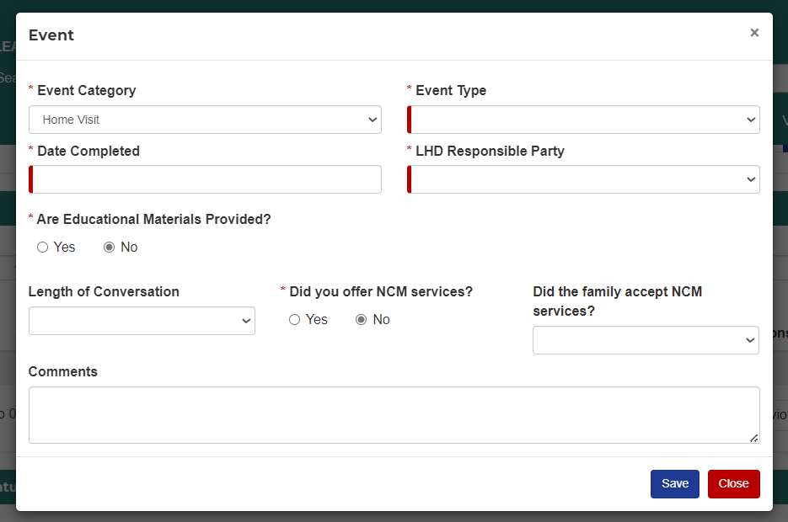

9.3.1.2 – Add Text event
A popup will open with the following fields:
- Event Category - Text
- Event Type
  - LHD contacted the parent/caregiver
  - LHD contacted the provider
  - LHD contacted community partners
  - LHD contacted MDHHS Nurse Consultant
  - LHD contacted other – comment required
  - Parent/caregiver contacted the LHD
  - Provider contacted the LHD
  - Community Partner contacted LHD
  - MDHHS Nurse consultant contacted LHD
  - Contact Lead Safe Home
  - Other contacted LHD – comment required
- Date Completed
- LHD Responsible Party
- Are Education Materials Provided?
- Did the Parent/Guardian respond?
- Did you offer NCM services? Yes, no – this question is hidden unless the parent/caregiver is selected in the event type
- Did the family accept NCM services? Yes, no, unknown/unresponsive - – this question is hidden unless the parent/caregiver is selected in the event type
- Comments
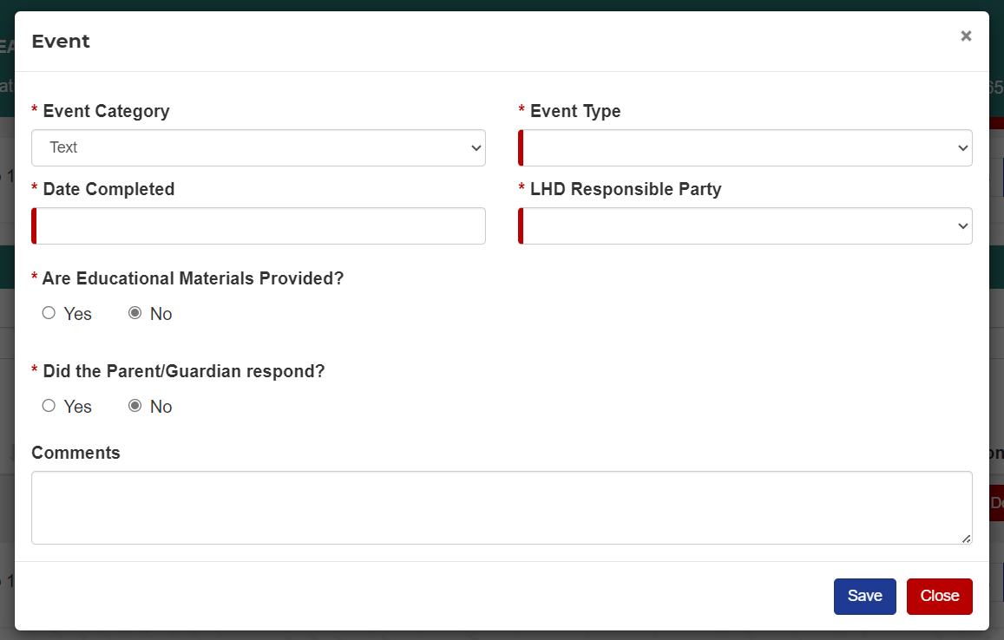
Additional questions shown when parent/caregiver is selected in Event Type
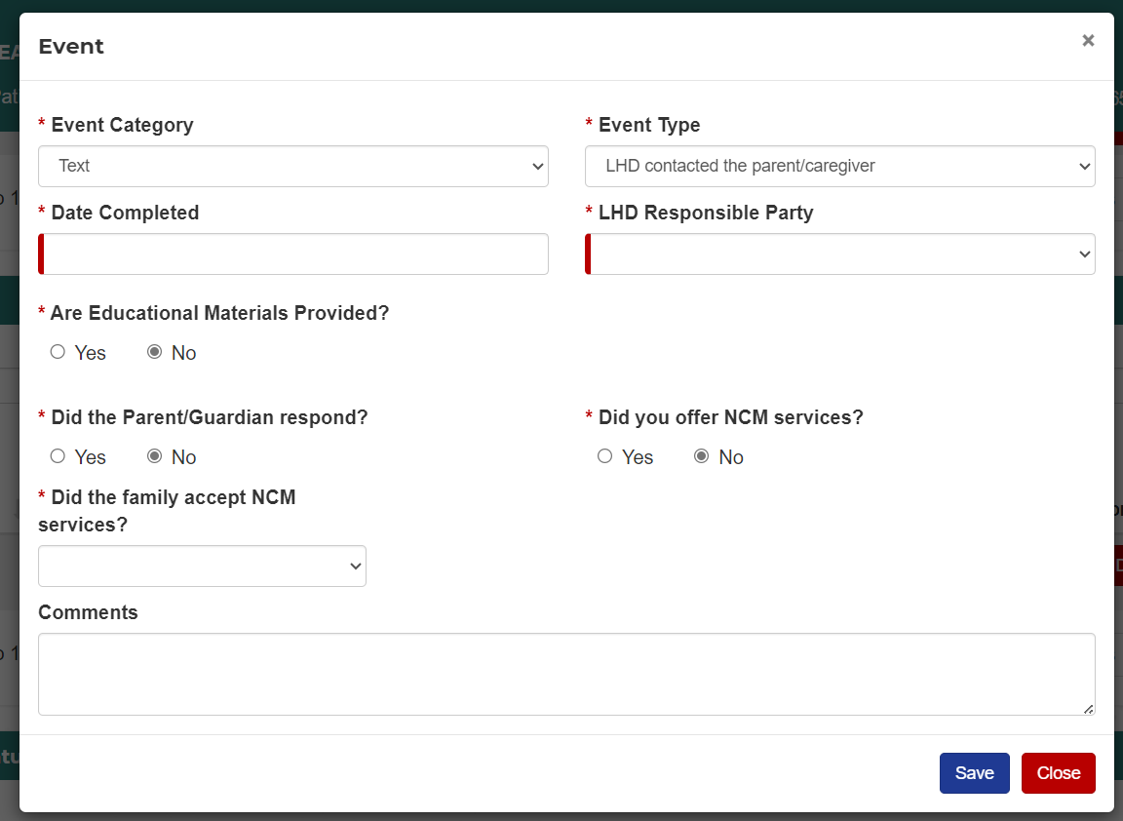
If the answer to Did the Parent/Guardian respond is No, then the answer to Did the family accept NCM services will automatically be filled in as unknown/unresponsive.

9.3.1.3 – Add Phone event
A popup will open with the following fields:
- Event Category - Phone
- Event Type
  - LHD contacted the parent/caregiver
  - LHD contacted the provider
  - LHD contacted community partners
  - LHD contacted MDHHS Nurse Consultant
  - LHD contacted other – comment required
  - Parent/caregiver contacted the LHD
  - Provider contacted the LHD
  - Community Partner contacted LHD
  - MDHHS Nurse consultant contacted LHD
  - Contact Lead Safe Home
  - Other contacted LHD – comment required
  - Health Plan
- Date Completed
- LHD Responsible Party
- Are Education Materials Provided?
- Length of Call
  - Unanswered
  - <5 Minutes
  - 15 minutes or less
  - 16 – 30 minutes
  - 30 minutes or longer
  - > 1 hour
- Did you offer NCM services? Yes, no – this question is hidden unless the parent/caregiver is selected in the event type
- Did the family accept NCM services? Yes, no, unknown/unresponsive - – this question is hidden unless the parent/caregiver is selected in the event type
- Comments
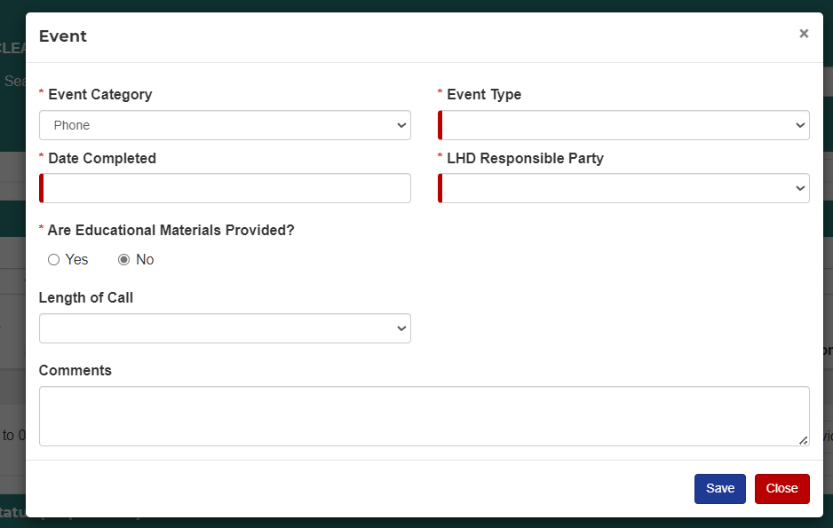
Additional questions shown when parent/caregiver is selected in Event Type
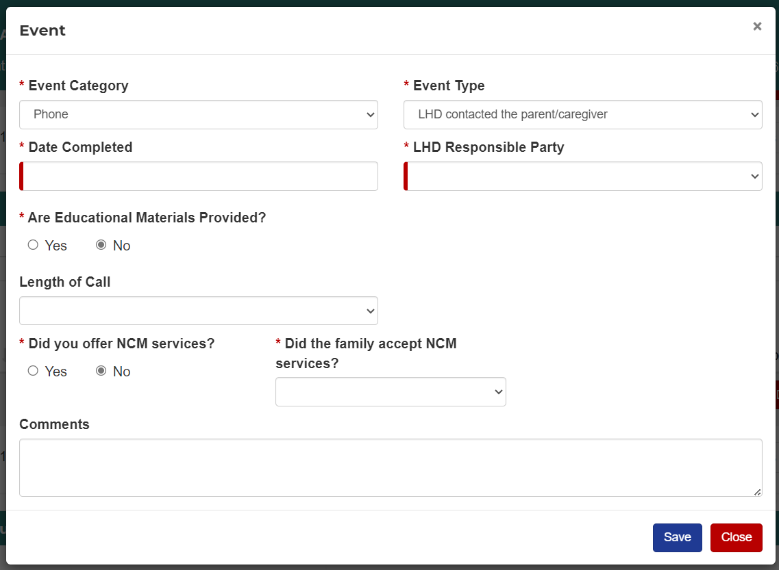

9.3.1.4 – Add Letter event
A popup will open with the following fields:
- Event Category - Letter
- Event Type
  - Family Case Closure 3.5
  - Family Confirmatory Venous
  - Family Opted Out NCM
  - Family Unable to Reach
  - Redraw Letter
  - Provider CM Complete
  - Provider CM Declined
  - Provider Unable to Reach
  - Letter Sent to Other – comment required
- Date Completed
- LHD Responsible Party
- Who was the letter sent to – checkboxes, multiple selections can be made. Each selection will create a separate event. The selections are:
  - Parent
  - Provider
  - Medical Health Plan
  - Other – must fill out the specify box
- Are Education Materials Provided?
- Sent Parent Letter Returned – checkbox – this question is hidden unless parent is selected in letter sent to
- Did you offer NCM services? Yes, no – this question is hidden unless parent is selected in letter sent to
- Did the family accept NCM services? Yes, no, unknown/unresponsive – this question is hidden unless parent is selected in letter sent to
- Comments
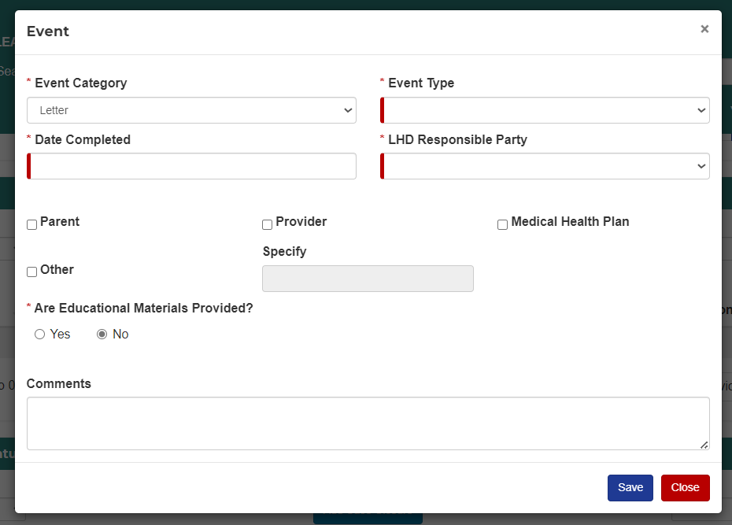
Additional questions shown when parent is selected as letter sent to
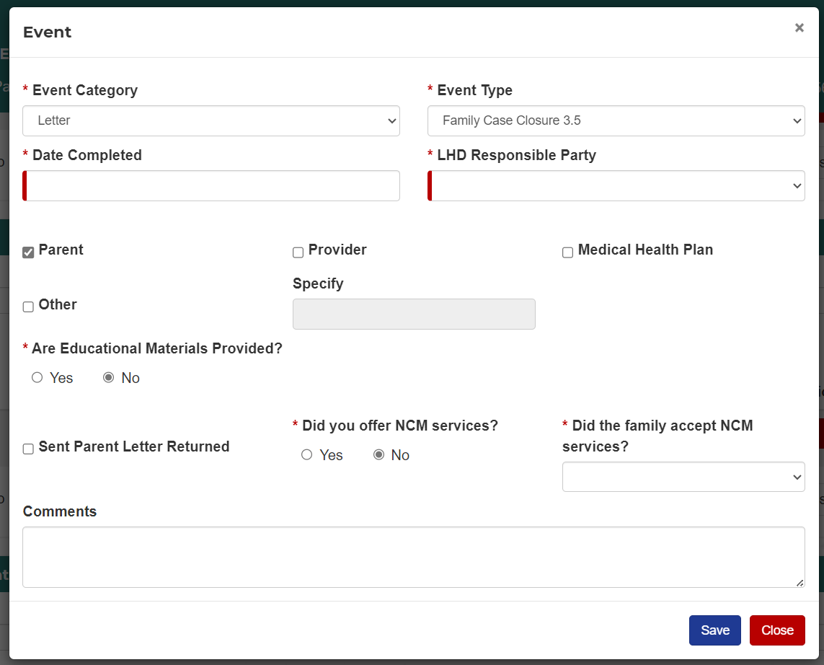

9.3.1.5 – Add Interventions/Other event
A popup will open with the following fields:
- Event Category – Interventions/Other
- Event Type
  - Educational Materials Provided
  - Case Review- used when Nurse Consultant or Local Health Department Case Manager review case, but no changes or outreach is performed
  - Care Coordination
  - CPS contacted
- Date Completed
- LHD Responsible Party
- Are Education Materials Provided?
- Comments
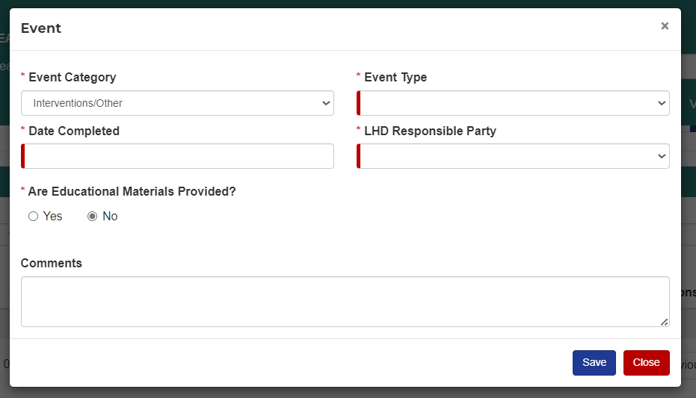

9.3.1.6 – Add Referral
A popup will open with the following fields:
- Event Category - Referral
- Event Type
  - Nutrition
  - Health
  - Child Development
  - Housing
  - Financial Support
  - Insurance
  - Legal
- Date Completed
- LHD Responsible Party
- Are Education Materials Provided?
- Did you offer NCM services? Yes, no
- Did the family accept NCM services? Yes, no
- Referral Subtype
  - Nutrition
    - WIC
    - MiBridges
    - Other
  - Health
    - Primary Care Provider
    - Behavioral Health
    - Mental Health
    - Infant Mental Health
    - CSHCS
    - Medicaid Health Plan Case Manager
    - Other home visiting program
    - Other
  - Child Development
    - Early On
    - Other
  - Housing
    - SER
    - Lead Safe Home Program
    - Local abatement services
    - Community Action Agency
    - Vouchered Housing
    - Local homelessness resources
    - Other
  - Financial Support
    - MiBridges
    - Other
  - Insurance
    - Medicaid
    - Other
  - Legal
    - Other
- Referral Date
- Reason for Referral
- Name of Agency
- Contact at Agency
- Comments
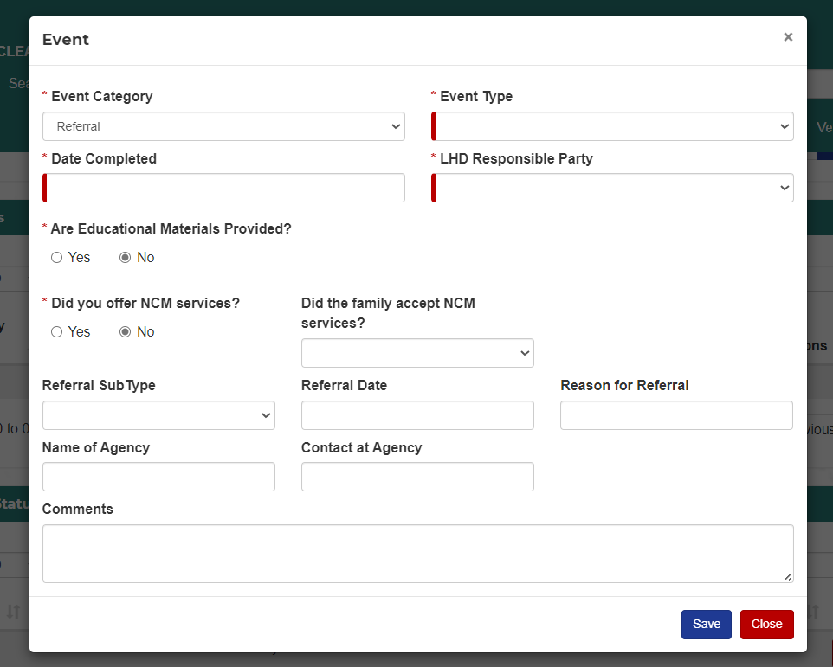

9.3.1.7 – Add Email event
A popup will open with the following fields:
- Event Category - Email
- Event Type
  - Family Case Closure 3.5
  - Family Confirmatory Venous
  - Family Opted Out NCM
  - Family Unable to Reach
  - Redraw Letter
  - Provider CM Complete
  - Provider CM Declined
  - Provider Unable to Reach
  - OTHER letter sent – comment required
- Date Completed
- LHD Responsible Party
- Are Education Materials Provided?
- Did the Parent/Guardian respond?
- Did you offer NCM services? Yes, no
- Did the family accept NCM services? Yes, no, unknown/unresponsive
- Comments
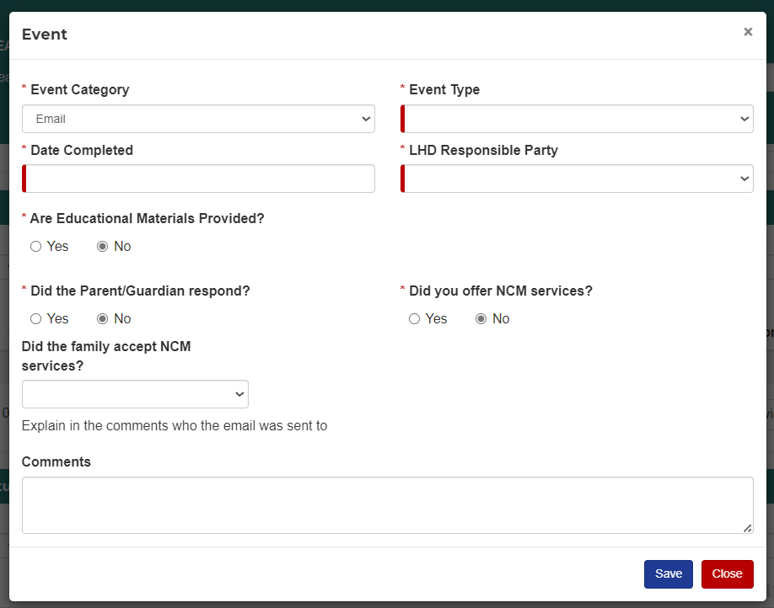

9.3.1.8 – Add In Person Contact Attempt
A popup will open with the following fields:
- Event Category – In Person Contact Attempt
- Event Type – Contact Attempt
- Date Completed
- LHD Responsible Party
- Are Education Materials Provided?
- Length of Conversation – how long was the contact
  - <5 Minutes
  - 5 - 15 minutes
  - 16 – 30 minutes
  - 31- 60 minutes
  - > 1 hour
- Did you offer NCM services? Yes, no
- Did the family accept NCM services? Yes, no, unknown/unresponsive
- Comments
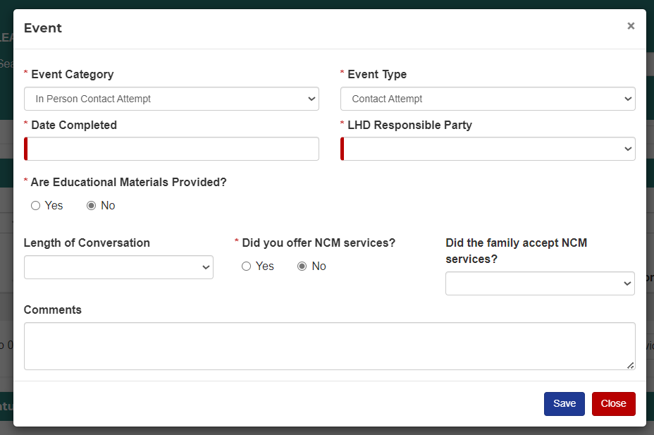

9.4 – Case Status (Disposition)
The Case Status section shows a history of all changes to the status of the case.
A change in Case Status will add a row to the table.
A change in Case Type will add a row to the table.
The following fields display:
- Status – Case Status – Open, Closed, Unconfirmed, Not A Case
- Case Type – Eligible, Managed
- Date – date of status change
- LHD
- BLL – latest BLL record
- Closed By – if status changed to closed this will show who updated the status to closed
- Reason for Closure – the reason the case was closed
- PHN Closed – has a Public Health Nurse signed off on the closure
- Action - Edit
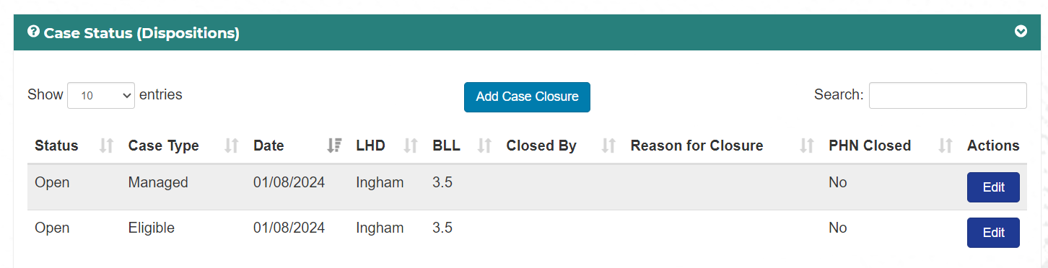

9.4.1 – Add Case Closure
To add a case closure, click the Add Case Closure button. A popup will open with the following fields:
PHN Case Closed – checkbox, this is where a PHN will indicate they have reviewed the case for proper documentation so the case can be closed
Case Closed – Date the case was closed
Reason for Closure
- Case Closed - Refused
- Case Closed - Unable to Contact
- Case Closed - Moved Out of State
- Case Closed – Plan of Care Completed
- Case Closed - Other
Specify – required if Other is chosen
Notes – notes on case closure
