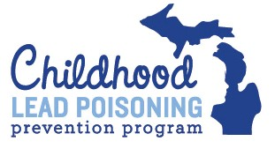

How the CLPPP Nurse Consultants Can Assist You
The Nurse Consultants are available to assist with training, documentation, case discussion, and all questions pertaining to case management.
When requesting assistance reach out to your Nurse Consultant assigned to your region first. If your assigned person is out of the office, then proceed with contacting one of the other Nurse Consultants. (Nurse-Consultant-Coverage Map)
All requests related to case management should be sent to your Nurse Consultant. Data related requests, including but not limited to local health department jurisdiction, zip code level data, BLL, should be sent directly to the MDHHS-CLPPP@michigan.gov email address. An individual from the Lead Data Unit will respond to your request and ask for additional information as need.
- Request consultation on case
  - Consultation on Lead Safe Home Process (relocation, where home is in abatement process)
  - Complex case
  - Chelation case
- Request additional visits
- Request case conference
- Request training
  - Lead 101
  - NCM
  - Database
  - Lead Safe Home
  - Other trainings may be offered depending on identified needs
*General questions and inquiries can always be emailed directly to your Nurse Consultant.

